Préface

AIR IN DANGER
_______
_____

In Memoriam

To Haroun Tazieff

who realized too late that
frequentation of the air-conditioned hotels
is much more dangerous
than that of all the craters
volcanoes of planet !

Although frequentation of the physicists
is surely hardly more resting,
he made me the honour re-examine
the manuscript of this work,
thus bringing to me the fruits
of a solid experiment,
and of a teaching talent
whose experts know the price .

May he find the insurance here
of my gratitude and my attachment
with our common combat.
May he find there too
feelings of friendship and regard
for the man whose courage never failed.

PREFACE OF
HAROUN TAZIEFF

I have the chance to be a species of tower of health. However, at the moment, I come back from Japan, from where I bring back an influenza harmful like all, collected on the foot of the Unzen volcano, which we had gone to study. But the eruption does not have nothing to do with this business: the influenza, which destroyed me during ten days, I collected it in an air conditioned hotel... A hotel with American - Japan, after Hiroshima and Nagasaki, aligned itself on the United States - hotel of glass and steel built on the site of the one of these traditional thermal baths, called over there o-furo, which strews this volcanic archipelago, hot water that all the population uses in an intense way and who are perhaps one of the reasons why Japanese are also solid. Therefore at least were it before the era of the air conditioning
Many are the people, doctors included, who for a long time realized that the " air-conditioned " air seemed in the beginning many colds, migraines, bronchi tides, influenzas, allergies. Everyone, or almost - and myself when I took this evil with Kyu-Shu at this beginning of August 1991 - believed that these diseases came from the cold in which, coming from an outside hot and wet, one was brutally plunged.
As which was not my surprise while reading in this book of Jacques Breton as the air conditioning was well, as much think it already, a harmful effect of great scale but not at all because of the differences in temperature: because of the particles microscopic, even ultramicroscopic, in suspension in any inhabited room. Some of these micropolluants are, by their nature even, aggressive, but those which could not have been it, are it because they transport pathogenic germs, virus, bacteria, moulds, etc
The air pollution is a thing which I know somewhat: since, vulcanologist beginning, I understood that the gases were, alone, the active element of the eruptions (and not lava which, for sumptuous that they are, are never but one entirely passive component) and that I consequently devoted the essence of my efforts to their study.
I thus did not fall, by reading the Air in Danger, in a completely unknown field of me. The more so as, as a departmental elected official, occupying me since a half-dozen of years of the questions raised by pollution in general - that of water, that of the grounds, but also that of the air - this micropollution is essential me as much as the macro pollution by particles larger than... microns, this micropollution that the modern society increasingly frightening product bulk. And not only industries but from now on each citizen: we all are pollutants
I thus knew various things, more certainly that the average citizen about the micropollution, but the book of Jacques Breton taught me much from it that I was unaware of. And above all, the pathogenic role of these micro particles and the major harmful effect that which is the " conditioning ", unceasingly, brews an air upon the departure vitiated by the positively charged particles which it carries, and becomes it more as it passes and passes by again by a humanity of which it collects not only the carbon dioxide produced by breathing, like all sweat, but also the germs which it carries in it or on it.
I learned the role from the positive ions and the negative ions, the generally harmful first, the second beneficial ones: this role, I was unaware of it completely. Breton, as a physicist, explains us in a very clear way it why and it how of this action, action negative of the positive ions, positive action of the negative ions ! This paradox is of a nature only semantic and, by reading Jacques Breton, you will understand that without sorrow no, even if you do not have any knowledge in these matters. It popularises excellent way indeed. It popularises like only, when they want to do it, the researchers can it. Because the only good " popularisation " of the science which that is to say can be the work only of the researcher himself, because only knows to him perfectly what it speaks. Better than whoever. Even most learned of the professors - a fortiori of the journalists, including those which are said " scientific ", cannot claim to control subjects which they do not know, at best, which with second hand, through original articles written by the researchers, but generally of third or fourth hand, by articles of popularisation, treaties or handbooks.
Another revelation of importance that Jacques Breton brings to us in this book, it is it why role, harmful for health, much more harmful than one thinks it, of the screens of television set, computer, minitel or text processing: always positive ions.
These warnings, and these scientifically rational explanations constitute a contribution which I estimate of first order at our knowledge of the dangers which surround us. But there is one " more " major importance: the discovery of the parade and how to protect itself: Breton Jacques, indeed, found the means at the same time of preventing and of curing the effects of the harmful effects generated by the particles with positive electric charge. He invented and developed an instrument of a simplicity which astounds me and which, in two seconds, replaces in the part where one starts it these harmful effects electropositive by the well-being which the negative oxygen ions get. Hundreds of million people all over the world will be able from now on to go well who, up to now, went badly.

Chapitre 1

AIR IN DANGER

CHAPTER 1

Nobody any more today can be unaware of, and especially nobody can deny any more that the air whom we breathe, is soiled more and more with impurities of which the quantity, the variety, but especially harmfulness, grow unceasingly. Exceeded by this situation, the official organizations, in particular the organizations of Health, are constrained to alert the population unceasingly, without him to offer the least sour or effective solution!....

Admittedly the urban, industrial or residential zones, are more severely reached; to however believe that the " countryside " is miraculously protected is a dangerous illusion; exhaust fumes of the vehicles, fume of the dwellings, pesticides or fungicides agricultural, invading plastics and urban dust transported by the wind, all that and much of other things maintain a slow, insidious but some degradation , of the places which we hope to have preserved .
Is it necessary besides to call that the diseases of the " allergic " type inter alia are not reserved only to the townsmen, but what they regularly gain ground in the no urban areas, particularly in the young children?
It is the presence unceasingly increasing - and regularly measured - atmospheric " pollutants ", substances or elements visible or usually invisible, present in the air which we breathe, who deteriorates the purity of this air; moreover, this deterioration can involve for the people concerned - but also for the domestic animals - immediate or differed harmful effects being able to become alarming: these discomforts appear in the form varied from sometimes severe persistent disorders for sensitive individuals, and serious pathologies if the pollutants are dangerous (asbestos, carcinogenic hydrocarbons....).
The whole of the particles - polluting or not - thus present in the air is generally called " aerosol ": it consists of inert particles of any origins, liquids and solids, and of bacterial or viral germs varied which we inevitably introduce.

We now know in an unquestionable way that this pollution is divided in two main categories, different at the same time by their nature and their effects: the " macro pollution " due to the " large " pollutants, and the " micropollution " due to the pollutants more " fine ", in general invisible with the naked eye.

Table 1, that we will comment on, gathers in a summarized diagrammatic form the compared characters of the two categories.

Table 1

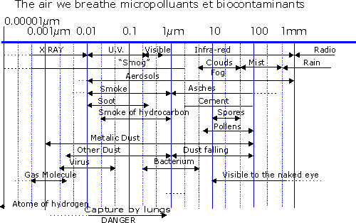

First of all let us retain a decisive difference between macro and micropollution. Of an average diameter higher than some thousandth of millimetres (micrometers), the weight of the macro pollutants obliges them to fall spontaneously towards the ground, (one says " to precipitate " or " to form a deposit"), thus removing the atmosphere from their presence.
It is the case of the majority of " large " dust, industrial and domestic.
Moreover, the macropollutants hardly tend to be disseminated by the wind: their accumulation involves of this fact a possible local risk, generally momentary...
- Of a diameter varying from some millionth from millimeter (nanometers), with one to two thousandth of millimetre (micrometers) the micropolluants are enough light to remain " in suspension " in the air, even more calms; they can thus gain in particular without encumbers our air cells during respiratory movements.
Of course, the wind can disperse them at enormous distances (thousands of kilometres) because of their lightness which facilitates their rise towards the upper atmosphere. It is the case of the " orange-coloured rains ", brought by the foehn charged with dust the finest arrivals of the Sahara, and falling down with the rain which they color.
Certain particular geographical areas (boxed areas, " folding " slopes, etc.) are thus victims of the stagnation of the surrounding atmosphere in the form alas known and dreaded of the " smog ", dangerous cocktail of fog (fog), of fume (smoke), of bacterial or viral agents carried by the fine droplets which constitute at the same time an excellent support and a vehicle.
It is also the case, increasingly frequent and worrying, of the great agglomerations victims of the " layer of inversion" : this one maintains on the ground a made harmful fog of residues of combustion of the engines and heatings, acid micro-droplets of water, varied micro-dust and pathogenic germs, plus a quantity of ozone and oxides of nitrogen largely higher than the limits of healthiness... " alert " diffused by our media show well with what a danger we arrived... but also in front of what an impotence we are!
Resulting from the extreme diversity from their size, macro and micro pollutants require techniques of filtration strictly adapted to their characters:
- generally easy elimination of the micro pollutants, either spontaneous or by simple and in theory effective installations. They are hardly carrying germs, and of this fact are generally not very dangerous.
- extreme difficulty of elimination of the micro pollutants and the germs which accompany them; they require the use of systems complex, expensive, cumbersome, fragile, reserved in general for factories site criticize such as pharmaceutical products and micro-electronics in particular. These micro pollutants are then excellent vehicles for the majority of the infectious germs which they thus will contribute to spread; one will be able to then speak about a " aero contamination ", causes major epidemics that we suffer : influenzas, pneumopathies, etc. moreover they are often frightening " allergens ", causes of varied disorders, sometimes tough and serious (asthma, rhinitides...), at the sensitised individuals (allergic).
- Except rare exceptions, the macro pollutants are concerned very little with the electric phenomena of which the surrounding atmosphere is the seat, in particular because of the brevity of their stay in this atmosphere.
- A the reverse, micro particles - and of course all the micro pollutants - are most of the time strongly implied in these electric phenomena and there play an often essential role (storm...); they cumulate for our organizations the specific effects to their nature (allergic, chemical, bacteriological), and the fundamental effects of the electric charge which they carry (positive, most of the time).
- Except accidental case, the macro pollution misses our dwellings and generally of our places of work; it is unfortunately not the same - and far is necessary oneself some - micropollution: recent measurements, made in a systematic way using laser apparatuses of counting, finally made it possible to have an exact idea of the rates of particles present in an air which we thought and hope salubrious, or at the very least " breathable "...
The very serious surprise, the word is really not too extremely, was to note that the rates of micropollutants met in the closed buildings, whatever they are - your bedroom like your office or the waiting room of your station, the treatment room of your dentist, or the worse still operating room of such or such hospital complex! - these rates are always and almost without exception much higher than those which one meets in outside, even " very polluted .

The tables II and III summarize extremely well these observations, to tell the truth much more alarming than it appears, since the data of table IV concern bulkiest of the micropolluants, unfortunately fewer.
Table 2
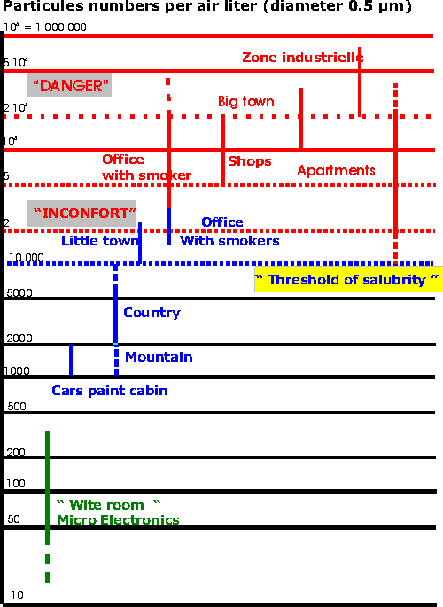

Table 3
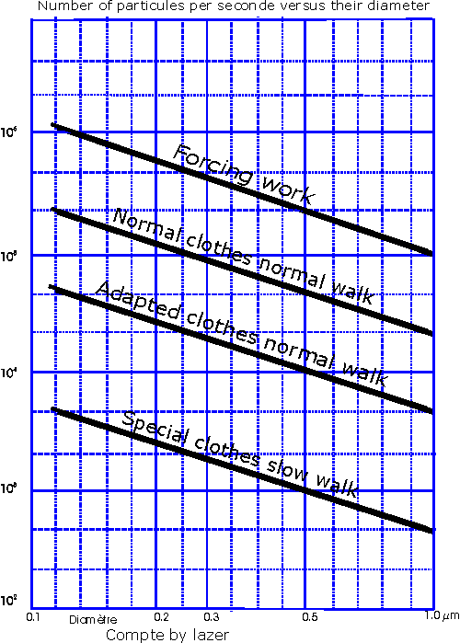
And this is confirmed perfectly by this table IV which shows us clearly that the micropollution increases of more than one factor 100 when the diameter of the particles passes from 0,5 to 0,05 thousandths of millimetre; still they are measurements in outside, where it is known that this micropollution is definitely weaker than in interior...

Table 4
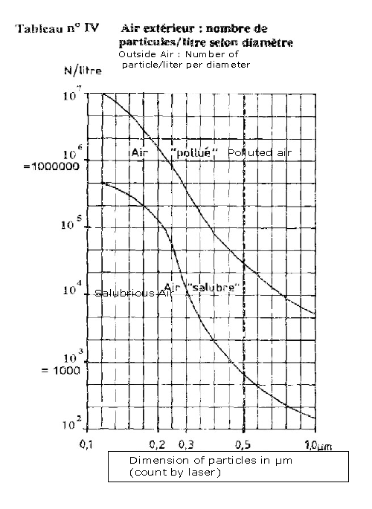
Circumstance rather aggravating : whereas in salubrious sites the external micropollution comes essentially from natural causes (wind erosion of the ground, vegetable micro fibres in particular), the interior micropollution results from the mixture of these contributions external and the many residues of the urban activity, with the too many interior " sources ": all our wall and floor coverings, furniture, our clothing, multiple familiar objects and... our own body which rejects the old worn skin unceasingly to make place with new.
To that, these hosts invisible but quite present are added who are molds, spores, bacteria and virus of any origins, without forgetting of course the dust mites always present, for which the responsibility in many allergies is well established.
Our possible consolation could then result from the hope to control one day either the sources of this interior micropollution, or the micropollution itself in the places where it prevails. We will further see this hope is founded and that to be an often abstract science, physics can also bring to us extremely concrete solutions... on condition which they are accepted and actually applied!
There is another type of interior micropollution a long time ignored if not neglected, over which a recent report of the Department of Health protection of the C.E.A. (Commission of Atomic Energy, France) very strongly the attention calls. It is radioactive pollution which it acts indeed here, the essential person in charge while being Polonium, solid radioactive "descendant" of the gas radon, natural radioactive body everywhere present, including in the dwellings.
Most recent work and investigations of the C.E.A. estimate indeed that only atmospheric radon represents approximately 50 % of the annual amount of radioactivity received by each one of us. In light, that means that the really received amount is of the order of the double of that which one had estimated until there, with all the consequences which an increased and permanent exposure to radiations involves.
What to conclude from that? Which measurements is appropriate to consider?
The C.E.A. remains extremely discrete on this subject, recalling however that the International Committee of Research on Cancer (C.I.R.C.) recently radon of " Category 1 classified ", i.e. recognized and defined its carcinogenic properties
We will reconsider this alarming problem after having considered " the new " pollutant which now makes speak about him for same reasons : insidious, neglected... but carcinogenic proven, asbestos powdery represents a largely widespread danger because of its use in architectural coating. Here still, one will have needed a serious epidemiological investigation, in accordance with too many pulmonary cancers " unexplainable ", so that - at least - are considered prevention or protection measures.
In these two cases, among so much of others, physics will offer a solution logical, effective to us, of which it will only depend on us that it is implemented. But let us not anticipate, because it now remains for to us to present the " purple passage "!
Who among us, perspiring and suffocating in a too exiguous room, one day of heat wave, did not dream very waked up of a heavenly place where an air delicately refreshed and learnedly distributed would finally ensure us of the working hours joyfully slackened, in the medium of a skilfully recomposed green decoration?
Then came the air-conditioners, humidifiers, ventilators, conditioners, which were to finally solve this famous and insoluble problem: fault of being able to build the cities in the countryside, one was going to install the countryside in the cities! One could then profit from this fresh air, healthy, vivifying, but alas out of attack for the majority, thanks to the wonders of technology.
Alas! If one believes the happy beneficiaries of them, but also of the organizations far from inclined to systematic pessimism, the situation is sufficiently alarming, even sometimes of a real gravity, so that the implementation of these devices of cleansing was urgently called into question.
We do not want to fight here modern means which could and should bring element of a real and appreciable comfort to us. On the other hand, we cannot have any kindness for devices whose recognized harmful effects are too often much higher than the awaited benefits.
Two recent reports, coming from qualified organizations, unfortunately confirm testimonies and the lived experiment of a number of increasingly many users.
It is first of all the INSERM. (National Institute of Health and Medical Research, France) which, in a conference held September 1986 and entitled " Diseases of the air-conditioners and humidifiers ", brings back the serious problems which these systems pose, in particular in hospital medium. The recycling of the major part of the circulating air, impossibility of retaining the infectious micro pollutants and germs which accompany them, the existence of true " culture mediums " in the vats of humidification, involve an unacceptable risk of dissemination of germs, of which some are particularly dangerous for an already weakened population of patients.
It is inter alia " Legionella " (involving a pulmonary infection sometimes mortal), " Serratia " and " Aspergillus " responsible for various pathologies of opportunity in hospital medium, all particularly resistant germs, easily disseminated, being able to cause striking down infections.
Precise examples of struck hospital complexes of true fatal epidemics are quoted in the report and the general conclusion of the specialists is at the same time very pessimistic and very alarming. It is clearly known as there that we do not have apparently to date any operational means able to ensure a complete safety of distribution of the air in hospital or clinical medium without speaking of course about the " great sets " of any nature (work, dwelling, etc.) The systematic aggravation of the infectious problems observed in all these establishments, after more than twelve years of vain attempts to contain them, confirms the conclusions of the Services of Health on our current incapacity to control this very serious problem....
The second report emanates from the I.S.T. (Higher Institute of Work, France, 1989) and dealt with " the quality of the air on the place of work ". Three away years, it joined in all points the conclusions of the report of the I.N.S.E.R.M.; it supplements it largely with given concerning the harmful effects tested by an increasing fraction of the people working in the confined buildings with " air conditioning ".
Same problem of dissemination of germs (the more or less serious influenza and other viral affections appear in good place), of more or less severe disorders (headaches, migraines, giddiness’s, persistent tiredness, disturb ocular, of the behaviour, irritability, losses of vigilance); the list of " faintnesses " still impressive, is confirmed here by an impotent medical profession to control the situation.
Such faintnesses inevitably lead to an increasing medical consultation, whose recognized corollary is an expensive medicinal over consumption, causes secondary faintnesses, generator of habituation, without for all this the " cure " is obtained; it finally has for ultimate perverse effect a loss of output and an increased absenteeism... We are definitely well far from the " air-conditioned paradise " so much hoped!
And it is today very seriously alarming to note that with the passing of years, and after the publication of these reports, the great organizations of Health do not cease any more launching cries of alarm also vain only free, the situation not having never ceased degrading itself in spite of the optimistic ....or interested advertisements...
And here that to increase this degradation, the proliferation of the screens of data processing occurs, always accompanied by a profusion of furniture, fitted carpet, plastic materials, which develop and maintain a strong electrostatic positive charge, of which we will point out the harmful character unceasingly.
We have today, by measurements with the laser, the proof that the interior micropollution is not only dependent on the external conditions ; it results especially from local circumstances depending on each inhabited place and can thus reach... but paradoxically well really a high value within an exceptionally pure external atmosphere. The fact of ventilating vigorously and several times per day the dwelling does not change anything with the situation then, and in a few minutes with more the " standard " micropollution reconstituted itself and perhaps worsened if a supplement of external origin harmful were then introduced.
We saw besides that this " obstinacy " of the micropollution to be settled in all places poses with certain " significant " industries problems extremely difficult and expensive to solve, the adopted solutions not being absolute reliability and the risks of incidents always present and often full of consequences.
We should absolutely also bring back a very recent series of work made in French and foreign hospital mediums, confirming the gravity of the situation of the people suffering from respiratory diseases, young children and old people particularly. On this problem, took place at Hospital BICHAT, Paris, in 1998, days on " POLLUTION ALLERGIES and HYDROCARBONS ". Work presented relates to primarily the " Stu-dies with epidemiological approach of many populations ", led in France and USA. These works highlights the significant increase in mortality by respiratory and cardiovascular diseases, correlated with the increase in pollution.
The hydrocarbons of Diesel aerosols prove to be a powerful primary allergen, and causes of sensitising for many other allergens (production of Ige and cytokines), alarming mechanism for sensitive people in an increasing number .
A series of work on " ASTHMA AND POLLUTION " are presented simultaneously at the Teaching hospital of Bordeaux. These works show a significant increase in morbidity and mortality in the micro polluted mediums, for usual conditions of life . One observes systematically an aggravation of symptomatology , even with a rate of pollution lower than the standards of the O.M.S. One also observes a risk very strongly increased for the children.
In conclusion, it thus proves that the harmful effects, even dangerous of the pollutants are established and indisputable, even in the case of small quantities, and without effect of threshold .
Moreover they involve, in the majority of the cases, additive and synergistic harmful effects. These effects and their aggravation are confirmed by most recent work
It now remains for to us to clarify a point of which it is in general very little a question in the congresses, conferences, declarations or directives alarming of the " quality " of the air on our dwelling or places of work. This point, generally considered " detail ", however relates to two made observations an incalculable number of times, and that no fact, no observation never contradicted.
- the first observation comes from the physicists of the atmosphere: they noted for a very long time, and checked by many experiments and measurements, the close connection existing between the electric properties of the atmosphere and the presence of aerosols (in general of the natural or technological origin micropollutants) in this atmosphere; these relations as well relate to the air of an office or a room to be slept that the atmospheric mass in which a storm will occur, on the scale close of course.
But that one retains this fundamental fact well: the mechanisms brought into play are the same ones, and have the nearly identical consequences.
The second observation relates to the relation existing between these two factors, micropollution and electricity, and the disorders, faintnesses, often permanent, sometimes serious, tested by a number growing people remaining in the buildings whose air was "conditioned ", even simply in their dwelling, which no " well indexed " cause manages to explain, and no " therapeutic " to relieve.
These disorders and faintnesses are however absolutely real, obviously in the process of growth, and they resist obstinately the chemiotherapic drugs, of which the side effects too often constitute an additional harmful effect!
Let us add the effects recognized by the medical profession - and dreaded by certain patients - particular climatic conditions, the such arrival of the foehn for the cardiopulmonary patients, and we will not doubt any more importance of such phenomena on our health, and of the absolute need for a rigorous approach on their subject.
Then, why silence on facts that it is not possible any more to dispute?
Without any doubt because they relate to two fields apparently very distant and thus without obvious relation : the physics of the atmosphere and the biology of alive, complex disciplines, prerogative of more and more "pointed" specialists, hesitant to leave the field of their specialty . Perhaps also because, concerning directly with health, the problem is not only of fundamental physics or biology...
At all events, the problem exists, more and more suffer from it daily, too often without recourse. Then this first assessment of the facts being established, we go, in the lines which follow, to endeavour to approach and to understand the mechanisms concerned, at the same time to satisfy a legitimate curiosity, but also to consider and propose effective solutions which us... nature suggests!

Chapitre 2

AIR IN DANGER

Chapter II

IN THE FORM OF RECALLS

1 - ONCE UPON A TIME... THE UNIVERSE

Thus started the tales, works of fiction, of pure imagination, intended to charm our childhood, to rock and fill our search of marvellous...
Who would ever have thought that Science, more precisely Physics, considered austere, based on the rigor, would propose " a history " more marvellous to us than any of that which no storyteller ever could imagine?
This history, it is our history, that of the birth and the life of this universe which we live the moment of a beat of wing, but that much labour and obstinacy enabled us to reconstitute the past since its whole first moments, and of which we better and better understand the genesis and the evolution.
Because this fabulously distant past will enable us to seize one present often diverting, and to show us that in this universe, nothing, absolutely nothing, depends on the chance, since most banal of the atoms until highest creations of the spirit.
Here thus soon fifteen Billion years that was born this thing as essential as the light and the matter: it is electricity, in the form that we know to him and who never varied since his birth. It is precisely in the very first seconds that appeared - numbers some rigorously equal - the electric antagonists" charges " , that we called - for want of anything better - " positive " and " negative ", from which is made up all the matter of our Universe.

We observe this extraordinary precaution which takes nature - or its Creator - certainly to lay out of two types of electric charges, with their own behaviours, but to create them in an equal number, so that the universe to come, you, me, and usually all that surrounds us, electrically remains " neutral ".
This fact will be precisely translated under the usual conditions by the absence of observable electric forces on our scale, while these same forces will ensure in a fundamental way the existence and cohesion of any matter on the scale of the atoms ! They was there certainly the two initial conditions most draconian to respect... but perhaps more " easy" !
Conversely, and as it would be necessary well to ensure the cohesion and the structuring of this universe, nature will have another force, everywhere presents, acting on all that exists or will exist: it will be the gravitation. It is there at every moment, and its presence recalls us unceasingly, and if I dare statement of what a weight it weighs on us !
However, here still, " lady Nature " will be shown very far-sighted: this force of gravitation, immensely lower than the electric forces, will act in perceptible manner and " structuring " only if considerable matter masses are gathered by it: planets, stars, galaxies to come.

2 - NOW ... ELECTRICITY !

Thus, this matter which surrounds us and we are made can exist and remain only thanks to the electric forces, then primarily gravitational, which are exerted between its components!
Thus let us see that of a little near, and profit to immediately locate the size of these forces, that never more we will not have to forget.
Each one knows that a metal is " conductive good " of electricity, whereas a plastic, for example, is excellent " insulating "! Why this difference?
Well, in a metal, the electrons - these tiny negative charges, light, leaping - can move very easily, under least requests : it is the usual " electrical current " ! Conversely, in an insulator, the electrons remain obstinately hung to their atom, not being able of this fact of transporting of " current " from a place to another.
What means these words then: " intensity ", " ampere "? Exactly the equivalent of the flow of a control, water, gas, expressed in litres a second for example. But here, it will be about the quantity of negative electric charges, therefore number of electrons, which pass to each second in an unspecified point of a conducting circuit, just like besides the " flow " of water in a pipe.
The unit of load is called " Coulomb ", and it was decided that if in a point of a circuit it passes to each second one " Coulomb ", the flow - here one will speak about intensity - will be " one ampere ".
Therefore a driver crossed by a current of one ampere, " will then see " a negative charge of 1 Coulomb passing to each second in unspecified of its points.
Very well, will you say to me, but we would be curious to know how much that, made electrons in promenade ?
.. A true statement : tremendously !! You want to know how much? Then see
1 Coulomb = 6 X 1.000.000.000.000.000.000 of electronic charges, is thus 6 billions of billion: I had said it to you, that made really much .
An ampere is thus many electrons, but however a weak current : just what to recharge the battery of your video camera! And yet......
Now let us imagine a theoretically possible experiment, perfectly rigorous but alas completely unrealisable with our means.
Let us imagine that we succeed in gathering - what already would hardly be convenient - two small " packages " of electrons, each package containing a charge of one Coulomb, very modest compared with that of a stormy cloud for example.
Then let us try to place our two packages of electrons at one meter one above the other or one beside the other. Of course, because of this fundamental law imposed by nature on their birth, our electrons between them, as well as the two packages, will be pushed back, such of the enemy brothers.
I told you the vastness of the electric forces: here is measurement, verifiable and always verified : our two packages will be pushed back with a force close to a million tons...
If, for example, you hung the first package of electrons to a (solid) gantry, and that you want " to suspend " the second package with one meter below the first, the " cable " of suspension will have to support the equivalent of 10 large aircraft carriers or 3 giant tankers!
Then, what do you think of the electric forces?!

I now will give you the example of a natural phenomenon well-known, and always not appreciated besides, where such forces, settings really concerned, explain the effects observed: it is the storm and more particularly the lightning. The latter is indeed nothing other that a package of electrons whose dimension is about a few centimetres; it transports a charge of a few tens of coulombs, driven out original cloud by the enormous accumulation of identical charges which precisely constitute the stormy structure. But we will further have the occasion to speak again about it.

Thus let us return to our individual charges and point out the two completely fundamental properties who organized any matter:
1 - Two charges of " same sign ", two positive protons, like two negative electrons, is pushed back more and more vigorously, when their distance decreases. When the distance is divided by 2, the force is multiplied by 4; when the distance is divided by 10, the force is multiplied by 100. It is said whereas " the force is inversely proportional to the square of the distance ". It is a law which thus leads to gigantic forces when the distance between the charges becomes very small. Only one load present in an unspecified place will be able to thus act on all the charges present in the space, therefore far which they can be... and reciprocally of course. At this force everywhere presents and able to be exerted on a charge as on the preceding " package ", one gave the name of " electric field ". And its law of variation is obviously that of the force : double the distance, it is divided by 4; multiply the distance by 10, it is divided by 100. Thus goes the electric field .
2 - With the reverse of the identical charges, two charges of " contrary sign ", a positive proton and a negative electron, attract each other mutually more and more vigorously when their distance decreases, and of course less and less when their distance increases! The force (and the field) are divided by 4 when the distance is doubled and it is multiplied by 100 when the distance is divided by 10. This force of attraction thus obeys the same law that the force of repulsion, varies very quickly with the distance and conduit to gigantic forces of attraction when the distance is very small.
And now, an atom of hydrogen, it is what?
Question for question, what is a sling?
Approximately, a stone at the end of a lace, held well by that which makes turn stone quickly. One sees the lace then being tightened and provided that the stone turns rather quickly, it can indifferently do it in a horizontal, oblique, or vertical plane!

Here (about) an atom of hydrogen: the stone which turns, it is the electron, while you who maintain it on his trajectory, you are (or rather your hand) the proton, the " core " of the atom; as for the force which maintains stone around you, it is the tension exerted by the lace, equivalent to the electric force of attraction: without it, or if you cut the lace, the " stone-electron " will slip by straight and you will not re-examine it probably more !
Only precaution, but completely essential, taken by nature: to make so that the electron turns just at the good speed so that the " centrifugal " force, which tends to move away it, balance exactly electric attraction !
Apparently, it is successful, and the hydrogen of the universe behaves wisely, at least as a long time as one does not try to subtilise " his " electron to him !
Einstein often said: " What is good for the gander is surely good for goose." It is fortunately the same in the small world of the atoms.
When the core is weighed down, comprising 2, 3, to 92 protons (for uranium), an exactly equal number of electrons will circulate around the core, in an extraordinary ballet which was regulated meticulously when the spectacle started.

Thus for example, oxygen comprises a core containing 8 protons, around of which, in normal time, 8 electrons revolve wisely ; the nitrogen has a core with 7 protons, around whose 7 electrons circulate not less wisely. (Fig....)

Let us notice again that the fundamental rule will be thus complied with: the matter of our universe, in its normal state, will be electrically " neutral ", having an equal number of positive and negative charges, and not being able - at least in the general information of the cases - to be subjected to electric forces of external origin. All things considered, to have a stable universe, balanced, it was necessary at all costs " to muzzle " this electric force, by releasing the support a little if that became essential!

Before further going, let us point out an astonishing law concerning the constitution of the atoms and the distribution of the electrons around the core: in fact, as of the first elements, the electrons are divided into successive " layers ", the such onion skins. All things considered, rather than to pile up them on the same layer, by leaving an unutilised enormous vacuum between them and the core, nature preferred as well as possible to use the place it had; it benefited from this advantageous provision to equip the atoms with some additional properties, extremely invaluable for the future.
One of these properties, undoubtedly remarkable, is the irresistible tendency which have all the atoms, when that their is possible, to surround by the last layer of electrons, most external, comprising 8 electrons, not one moreover, not one of less! For the solid elements, it will not be easy, except for some atoms such carbon, silicon, suitably associated.
On the other hand, the gas elements will reach that point by a means as old as the world: by sharing their " resources " in electrons " Lends to me two electrons, I will lend to you two electrons" !

Thus will make oxygen, as the figure (very) diagrammatic shows it table N° VII. Thus will make in the same way nitrogen, chlorine and some other atoms with which definitely loneliness is unbearable!
Table 7
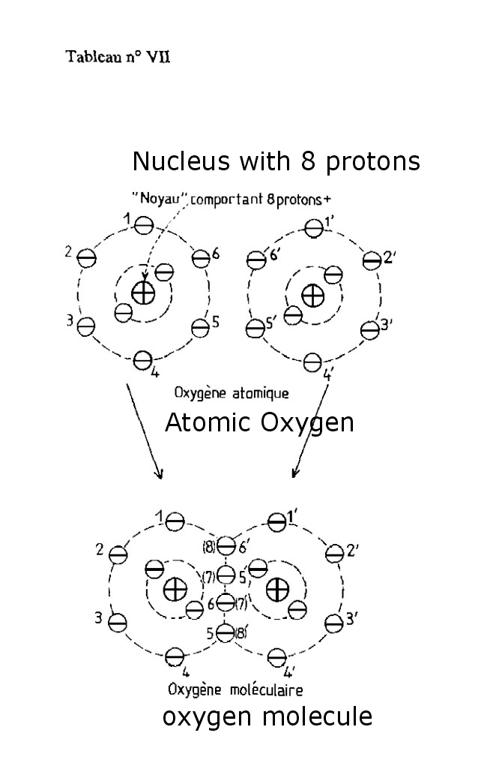
And do you know how one names such an association, completely stable and, would dare one to say, happy to live? Quite simply a molecule!
Then, more surprise: composed primarily of oxygen and nitrogen, our atmosphere thus sees these two gases present in their " molecular " form.
Of course, two different atoms can join (by " lending itself " electrons) to also constitute beautiful and good molecule from which the properties will be however always completely different from those of the atoms which constitute it!
And then, my faith, why not? 3, 4... 10,100, of the thousands of assembled atoms would constitute as many molecules with their structures, their properties, variables besides ad infinitum, which would leave with nature any freedom exert an imagination.....of which we are one of the fruits !
But let us return now to simple molecules, with 2 identical atoms, since it is precisely those which constitute this atmosphere which is the object of our concerns.
We know that in its normal state - the physicists say " fundamental " - atom or molecule is neutral electrically.
What will it occur then if an external cause causes either the profit, or the loss by " wrenching " , of one or several electrons? Of course, the atom or the molecule thus modified cease at once to be neutral electrically:
- the " profit " of one or several electrons confers a surplus negative charge systematically: it is said that one obtained a " negative ion ";
- the loss of one or several electrons results in the absence of neutralization of the corresponding positive charges of the core; the atom or the molecule thus treated has the corresponding surplus positive charge now. It is said that one obtained a " positive ion ".
Thus, a " ion " is nothing other than an atom or a molecule which gained or lost one or more electrons. Table N° VIII illustrates this.
Table 8
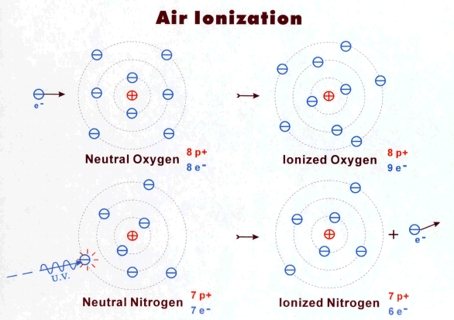
But then, attention with the consequences!...Generally, the neutral atom or molecule was unaware of the electric forces, remaining wisely where it was!
Charge carrier, our ions could be subjected to electric forces, in particular coming from their own mutual influence; if nothing retains them where they are, they will be put at once moving, in order to as fast as possible deviate from/to each other since they carry the same charge .
Thus, if they are in the vicinity of the same charges signs, they will tend to flee them.
But if they are in the vicinity of charges of contrary sign, they will tend to join them and " to neutralize them ".
Of course, these positive or negative ions could also be captured and will undoubtedly be it by the small or large particles present in the atmosphere according to a studied mechanism of long date by the physicists: the effect " of electric image ". The micropolluants will obviously not escape this phenomenon and I do not need to insist that you deeply imagine the consequences of this capture on the behaviour deeply upset of these micropolluants; the inevitable additional effects resulting from the presence of an electric charge will be able then to be fully exerted; furthermore, such effects, as well physical as biological, will be often very different according to the sign from the acquired charge.
It will then remain to ask us which precise causes are responsible for the transformation of an atom or a molecule into a charged ion, mechanism called " ionization ". Concerning gases of the atmosphere, we will see that these causes are varied, but that they always lead to the same result: for a long time to ensure within this atmosphere the permanent presence of the essential electric charges , already present when the life appeared on our ground, and which did not cease any more accompanying it and to take part in it.

Chapitre 3

AIR IN DANGER

CHAPTER III

THE BLUE PLANET

1 - BIRTH AND LIFE OF AN ATMOSPHERE

It is old, almost as old as the Earth as it wraps and protects as well from the mortal cold of the space as of the fatal radiation of the Sun...
Because if it distributes us without reserve vital oxygen, we forget too easily which delicate balances it has the role of maintaining, allowing the life to open out and triumph since soon three billion years.
It protects the Earth and it was born from the Earth !
But what is necessary for the life - in any case with that which occurred on our Earth - to appear and develop, to build increasingly complex organizations and to lead to the intelligence?
Three fundamental elements: carbon, hydrogen, oxygen. It will be necessary to associate to them a little nitrogen, phosphorus, calcium, iron or magnesium, some pinches of elements with subtle functions... and all will be able to start!
Remain however two large, very big problems, which it will absolutely be necessary to solve, so that the life does not keep a completely primitive form, confined in the marine environment protective, feeder, but terribly constraining...
It is initially the problem of oxygen, essential at terrestrial organizations which it will ensure the supply in energy, making it possible to resist broad variations in temperature and ensuring the operation of complex bodies. But it is also and as much the problem of the intense ultraviolet radiation, poured with profusion by a young overflowing Sun of energy!
Because no organic life resists the degradation caused by such a radiation and the primitive, transparent atmosphere with the ultraviolet ray, would absolutely not have authorized the appearance of the least terrestrial life.
Then? He well, once again, after much from others, Nature - or his Large Organizer - will show us that she did not leave definitely anything randomly!
Remember: " ordinary " oxygen, that of which the primitive atmosphere comprises only some traces, counts two atoms: it is the molecule 02 .
But there exists also a very particular " variety " of oxygen whose molecule counts either two but three atoms: it is also a gas, ozone.
And it is there that the business becomes really extraordinary: how is born indeed ozone?
Quite simply, if statement is dared, starting from the molecule of oxygen struck by the solar ultraviolet radiation. Indeed, under the action of this radiation, 3 molecules of oxygen, cash thus 6 atoms, will give 2 ozone molecules: the account is good.
This occurs in fact at high altitude (above twenty-five kilometres), where ozone thus could settle.
Is this all? He well not! Because essence will come now this ozone, which has just been born under the impact from the solar ultraviolet ray, is a body strongly absorbent of this solar ultraviolet ray, in particular " hard " radiations more, mortals for any living organism.
Thus the loop is buckled, and this molecule of oxygen - moreover passably extraordinary - will bring all for which the life had an imperative need to develop out of water. Indeed, after essential oxygen will have been gradually set up, the " layer " of ozone, which will not cease any more being present, will let filter and arrive on the ground only very weak quantity of ultraviolet ray, whose alive world will be able to be protected... and which it will use if necessary for its needs!
If it is thus an essential fact of which we are henceforth absolutely certain, it is that our life - or our survival - holds with two small things that we were forgetting: a beautiful colored molecule, the chlorophyll of the plants, creative permanent of essential oxygen, and a thin layer of ozone very old and very fragile.
However, without this layer of ozone, no more chlorophyll, without chlorophyll, no more oxygen, without oxygen, no more life. In front of that, we cannot ANYTHING.
What do you think about it?

Thus, it is absolutely certain that, without ozone, no life could have been born and develop on our planet. He well, it however should be recalled that ozone is also one of the natural substances most completely unsuitable maintaining the life, and that it is with the surplus perfectly able to destroy it....
Remember: an ozone molecule, it is a molecule of oxygen thus comprising 2 atoms, which acquired a third atom of oxygen. Such a molecule is unstable, because it is created by absorbing an energy which it will store, as well as mini-bends; this energy will come here from the solar radiation always available, in other cases from sources of natural electric energy (storms) or artificial (generators of very high voltages, industrialists or others). In upper atmosphere, that gives us the protective coating about which I already spoke you: the effect is then perfectly beneficial, no doubt with that!
But here! In lower atmosphere, two micropolluants at least are too often pre-sent: hydrocarbon aerosols badly burned by our heating's and our engines, and various oxides of nitrogen born of the high temperature of the gases burned and rejected into the atmosphere. Under the influence of the solar radiation and in the presence of these two pollutants, true accessory, our local oxygen is transformed into ozone, whose biochemical properties do one of the most dangerous pollutants than we have to fight or avoid. Why that?
Because ozone is " oxidizing " terribly powerful. In the presence of materials, inert or alive, able to fix oxygen (that with which our organization is abundantly furnished), ozone breaks up immediately into an " ordinary " molecule of oxygen, without particular effects, and a " oxygen incipient " in form atomic, able to burn literally and irremediably all that it will reach. It could be for example the mucous membranes of our respiratory tracts, or the cornea of our eyes, whose natural defences are alas completely impotent opposite this aggression. And this with concentrations as weak as 1 ozone molecule for 10 Million molecules of air. However atmosphere of many urban or industrial sites, or that of closed buildings in which a photocopier functions, comprise ozone rates exceeding too often largely this value.
Element to be protected at all costs in upper atmosphere, it thus proves which ozone is the element to be eliminated at all costs from the air that we breathe... and which of course we must absolutely avoid to get in !
We do not have there, once again, one of these extraordinary paradoxes which nature seems to be attached to our benefit... and often also for our distress?!

2 - AND SINCE ALWAYS... IONIZATION

Above all, point out what is our atmosphere today: a mixture of 80 % of nitrogen (N₂) , 19 % of oxygen (O₂), 1 % approximately of argon and other rare gases, vapour of water and multitude of undesirable products which we do not cease pouring there! Let us not forget obviously carbon dioxide (CO 2 ), unceasingly rejected by the volcanoes but also residue of combustions, whose temperature regulator role of our sphere is an extreme subject. Here for the actors.
Each one of them has, if I dare statement, its character, its manias. Thus, oxygen is extremely fond of delicacies electrons; you will have thus much sorrow to find an electron solitary ambling in the countryside. As soon as appeared, as soon as devoured by a molecule of oxygen which becomes thus the " famous " negative ion which we will write henceforth (do not forget, the physicists are sparing): (O₂⁻) . However this ion is very stable and lasts long " life" : its possible effects are obviously increased by it by as much. Let us add that it readily joins several molecules water, that the ambient air contains always more or less, thus giving a very mobile " small ion ", very sensitive to the presence of foreign electric charges, in particular positive.
Conversely, the nitrogen is not fond of delicacies electrons. If of adventure you manage to him to hang one of them, it gets rid some in less one millionth of second! Of course, struck by a radiation, the molecule of nitrogen of the air loses an electron and gives a positive ion (N₂⁺) . Although shorter than that of the ion (0₂⁻), the " lifespan " of the ion (N₂⁺) is sufficient to enable him to exert its influence on the other components of the atmosphere. Decided well to find its neutrality one moment compromised, our molecule (N₂⁺) goes, benefiting from the presence of various undesirable molecules (sulfuretted compounds, oxides of nitrogen, etc), to take an electron on an innocent atom of hydrogen implied well in spite of him in this business. Its achieved larceny, our molecule of neutral nitrogen become again... and anonymity, will await the next impact wisely, while hydrogen, become positive proton, will hasten to hide its nudity... in water!
Conversely, the nitrogen is not fond of delicacies electrons. If of adventure you manage to him to hang one of them, it gets rid some in less one millionth of second! Of course, struck by a radiation, the molecule of nitrogen of the air loses an electron and gives a positive ion (N₂⁺). Although shorter than that of the ion (0₂⁻), the " lifespan " of the ion (N₂⁺) is sufficient to enable him to exert its influence on the other components of the atmosphere. Decided well to find its neutrality one moment compromised, our molecule (N₂⁺) goes, benefiting from the presence of various undesirable molecules (sulfuretted compounds, oxides of nitrogen, etc), to take an electron on an innocent atom of hydrogen implied well in spite of him in this business. Its achieved larceny, our molecule of neutral nitrogen become again... and anonymity, will await the next impact wisely, while hydrogen, become positive proton, will hasten to hide its nudity... in water!
It will reach that point while being surrounded of a certain number of water molecules always present, thus giving a "small positive ion " to long lifespan... except capture by the micro pollutants or the ground. Not simple, this genesis of positive ions! Admittedly, but thanks to the presence in the air of four molecules of nitrogen for a molecule of oxygen, four chances to have an electron easy to obtain, captured at once by a perfectly miserly oxygen as of his, and thinking only of becoming a negative ion!
That lasts since more than three billion years, and the birth and the development of the life on ground obviously integrated this completely fundamental factor.
Well! We thus have an air containing a certain proportion, very stable moreover, oxygen ions with its own characteristics .
But we also have " on the arms" aqueous" positive ions (H⁺) of which we would like to know what to make! Patience! Nature took care of the problem, in order to preserve the ions oxygenates, for which it had remote but precise projects.
Let us reconsider one moment the structure of our atmosphere.
Table N° IX schematises the situation created by the positive loads coming from the Sun and by the storms, and the consequences which it comprises: the ground will invincibly attract the positive loads of the vicinity and will push back the negative charges. : the ground will invincibly attract the positive loads of the vicinity and will push back the negative charges.
A state of local balance will settle then; in the absence of additional sources of electrons, " small positive and negative ions " will be of about equal numbers, with a light prevalence of the positive ions near the ground, numbers close to the thousand per cm 3 of air, extremely stable value in not polluted natural environments. In the presence of " additional " sources of electrons (which we will see soon), it is the prevalence of a negative ionization of the air which one observes then, with a certain number of consequences of which we will also speak again.
But that one is not mistaken there: such mechanisms do not function in a way regular, harmonious, only if the air remains pure of any stain, accidental or deliberated, and in the absence of strong disturbances. Is it then surprising that the behaviour and the state of the alive beings are subject to the same rules?
Table 9
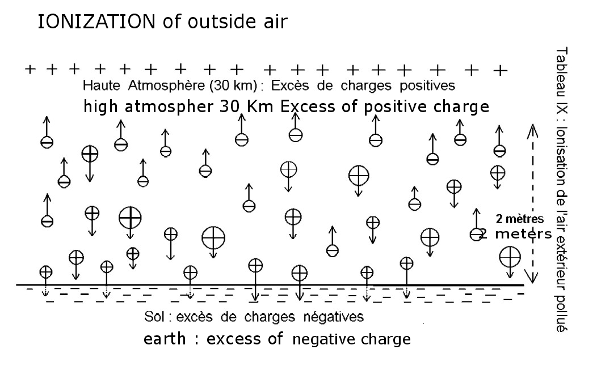

A question came certainly to you to mind since already a moment: these ions of oxygen and nitrogen whose reality isn't obviously contestable, from which thus come they, which created them?
If you look at table N° X, you will see gathered the natural causes of the ionization of the air, that one can group in two categories.

Table 10

1 - Causes implementing a very energy radiation or particles: cosmic rays, solar U.V., natural radioactivity of the rocks, radon contained in the air. In all these cases, an electron will be torn off by the " shock " of the incidental particle or by " the impact " of the radiation, giving of course rise to a " pair of ions" : they will be generally a positive ion nitrogenises and a violently expelled electron, but which will very quickly be acquired by a molecule of oxygen becoming thus a negative ion (0₂⁻) . The number of pairs of ions thus created varies, on the sea level, from two to a few tens produced per second and per millilitre (or Cm³) of air.
2 - The other natural causes, which operate with energies much weaker, but whose contribution is however essential, though variable with the place, are:
- the chlorophyllous function of all the plants which leads in particular to the rejection of (0₂⁻) in the atmosphere.
- the Lenard effect, concerning the rain and the cascades. The friction of the air on the water drops, the impact of those on the ground or the rocks, tear off electrons with these drops; their positive load is captured at once by the ground while the electrons of course are immediately trapped by oxygen.
- the effect of point or Corona effect: the positively charged upper atmosphere unceasingly attracts the electrons, those of the ground in particular. Any object fixed on the ground and driver of the current, rising and finishing points some (lightning conductor, sheets of graminaceous and all conifers, etc.) will see the electrons come from the ground to accumulate at the top of the point and, under the influence of their mutual repulsion, to be torn off with this point and to gain the atmosphere to be captured at once there by oxygen (see table N° XI).
Table 11
- 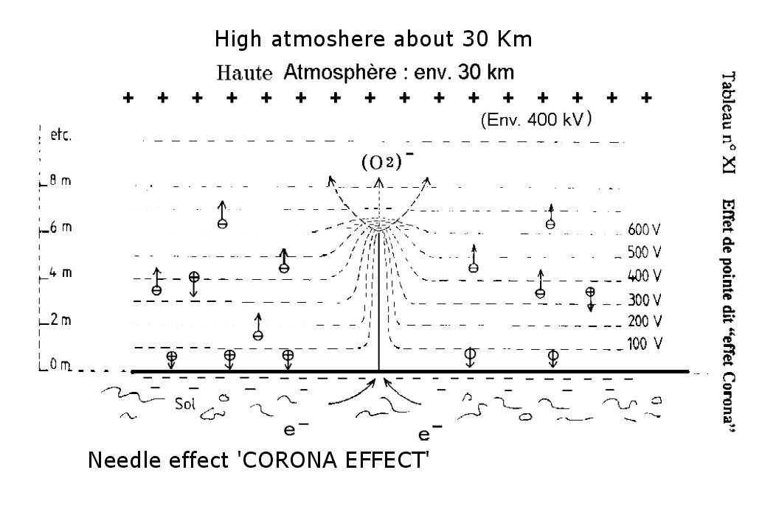

Well, very well, you say you! But to remove electrons of the ground unceasingly and to dispatch to him without stop positive charges, how can there remain to him still only one valid electron?
He well, for once, nature did not haggle over the means and the large spectacle offers to us: it is with the storm that it entrusted the responsibility to restore " wholesale" and very quickly what it gently takes on the ground .
Table N° XII is a diagram very simplified but faithful of this superb and noisy phenomenon. And the wonder is that once again, it is the water which will be responsible for this phenomenon!
Table 12
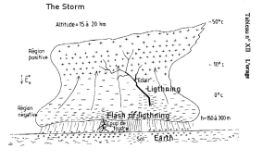
Water in drops liquidate with the lower part of the gigantic cloud (the typical " cumulonimbus"), the crystals of ice to the higher part.
Agitating all that, formidable ascending draughts, of which all the measurements made by the embarked apparatuses on board planes, the gust proof, show that the crystals of ice of the top of the cloud have an enormous positive load, while the drops or droplets of the base carry a not less enormous negative charge.
What can it then arrive? Just until you wait. Torn off by the monstrous electric forces, packages of electrons are precipitated towards the positive parts of the cloud; the brutality of their passage violently overheats the air which becomes luminous about it: it is the flash; the shock of the air to the passage of the " packages " of electrons generates what well wrongly causes the most fear: thunder.
And the lightning?
He well, it is the same thing, except that the " packages " of electrons join the ground, with great crash, thus restoring blow by blow to him the invaluable electrons which it will again be able and unceasingly to redistribute in the atmosphere (in fact, 90 % of the thunderbolts are " with electrons").
Our Earth being prone daily to several thousands of storms, it never risked, and does not risk more, to miss electrons!...
With this " refill " of the Earth - in fact, of its surface primarily - a strong injection of electrons in the lower atmosphere is added, under the effect of the abundant rains which accompany in particular the end of the storms: this circumstance makes it possible to restore quickly and intensely the normal negative density of the air, that the initial phase of the storm had brutally reversed. Besides we will see at which point these successive phases resound on the physiological state of certain particularly sensitive individuals and crosschecks the observations made in artificially charged atmospheres, either positively, or negatively.

3 - IONIZATION AND MICROPOLLUTION

It was a long time difficult - if not impossible - to as well measure with precision the ionization rate of the air as the nature and the quantity of micro pollutants present.
Difficult to measure, the atmospheric charge is undoubtedly: it is always weak, very easily disturbed in particular by the measuring equipment if extreme precautions are not taken - and it requires at the same time delicate materials to use, rare operators having long experience, a careful interpretation.
This most probably explains the rather extraordinary divergences between the results obtained by the many biologists having tried experiments in artificially ionized mediums, but not having the control essential of the physical devices to be implemented.
It is fortunately less difficult to operate in external atmosphere and the results obtained are of a very good fidelity. In particular, it is noticed very quickly besides that ionization characterizes very definitely certain sites and makes it possible to observe very interesting correlations with their healthiness... or on the contrary certain duly recognized disadvantages.
In insulated countryside, in low altitude, the negative average density is 1 to 1,5 a thousand of ions (0₂⁻) by cm³ of air, also current value in forest of aired plain, where it can however reach 3 to 5 thousands per cm 3 the nature of the ground also playing a role on this level.
On average mountain (1000 to 1500 meters of altitude), in zones carrying conifers (fir trees in particular), the negative density is very often high: from 5 to 8 thousands of negative ions per cm 3 and can reach the 10 thousands.
In the presence of cascades where the wrenching of electrons involves the existence of very strong local densities: from 10 to 50 thousands of ions (0 2 - by Cm3 in a perimeter of several tens to a hundred of meters, according to the importance of the cascade.
Raised densities, from 5 to 10 thousands per cm³, are also recorded on snow, by sky clearly in particular.
In edge of sea, in calm weather and in the absence of spray, one finds from 2 to 4 thousands of negative ions per cm 3
On the other hand, the wind of sea bringing of the spray causes in general a brutal inversion of electric charge; pulled by the wind, the salted water microdots evaporates, leaving a salt grain positively charged (frictions on the air), enough light to remain suspended in the air and to accumulate there, thus involving the inversion of charge of the local atmosphere, and its consequences among certain patients.

We stop one moment to point out a fact of observation as fundamental as systematic. In all places where reign this atmosphere with strong density in " small ions ", generally with negative preponderance, the micropollution of the air is always weak, and even extremely weak , of less than 1000 particles per liter with approximately 2000, according to the sites, the ground, the wind. It is an interesting value there, to compare with the micropollution measured in our offices or our dwellings, where it is 100 to 500 times higher...
This astonishing relation between a negative density that it is necessary well to describe as strictly normal, and the weakness of the micropollution, is a physical fact completely some, but full of consequences. It characterizes, without any exception the places that the secular experiment recognized healthy, salubrious, even able to restore our failing health at the time of these too short stays which are the " cures "...
Let us add to that that the micropolluants met on these places are in near total of natural origin, and that, so the living organisms which introduce them developed very long date necessary immunizing defences.
Now let us cross this " threshold of healthiness " illustrated on table N° XIII, and enter a quite different world, not very attractive, but which is more and more that in which we live.

We observe there the brutal fall of the density of small negative ions ; from a few hundreds of ions per cm 3 of surrounding air, in urban sites " light " and deprived of sources of industrial pollution, this density falls at a few tens per cm 3 in apartments or offices not air-conditioned and without smokers, to break down with some negative ions per cm 3 extremely low residual value, in the air-conditioned buildings.
Serious in itself, in particular for the pulmonary gaseous exchange where (0₂⁻) plays an essential role, this shortage of negative ions is severely worsened by the presence of a positive charge in general considerable, systematically related to the presence of a strong density of micropolluants .
It is observed indeed that the positive densities, recorded in the places thus affected, are always higher than 1 a thousand of positive charges per cm 3 of air, and reach 5 thousands per cm 3 in certain buildings equipped with air-conditioning or ventilation.

Table 13
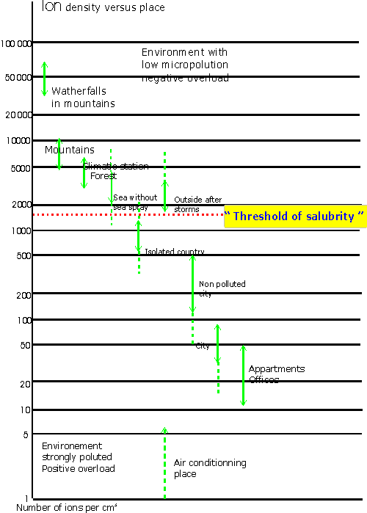

Such values are extremely alarming, and emerge besides for the people concerned, on multiple faintnesses or disorders on which it becomes increasingly difficult to maintain silence or the denial.
We will return there. But we must mark this stage in our progression well before, because it reflects at the same time a completely fundamental physical fact for our atmosphere and an extremely alarming situation for the future of our health. The two proposals which follow then summarize in a brutal but indisputable way the currently known experimental facts, in an unquestionable and systematically checked way :
- a salubrious atmosphere always has weak or very weak micropollution, joined to the only presence of small ions of the two signs, of which a negative charge higher than 1,5 a thousand of negative ions per cm 3 of air, presenting in addition quasi therapeutic properties for densities higher than 5 thousands of negative ions per cm 3
- an atmosphere found unhealthy always presents strong or very strong micropollution, joined to quasi an absence of small in particular negative ions, and to a clear positive charge higher than 500 large positive ions per cm 3 of air, generally ranging between 1 and 5 thousands of positive ions per cm 3

We now should understand the origin of such a situation if we want to give each other the means of bringing remedy there. For that, let us reconsider one moment the behaviour of the micropolluants and their relationships to the electric charges, in the closed places.
Table N° XIV summarizes the two essential mechanisms by which a particle present in the air is likely all to acquire a positive charge, preferably with a negative charge. We will deal here with the micropolluants present in an inhabited or attended room, since it is there that they will accumulate and that we will have to suffer from their effects.
Table 14
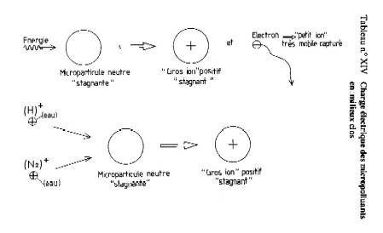
Same manner as in free atmosphere, the various radiations, radon, the abrasion caused by ventilation, will tear off one or more electrons with the present micro particles: those thus will acquire the equivalent positive load, becoming what the physicist Paul Langevin had called " large positive ions ". Unfortunately, these large ions are far from mobile, in any case not more than the particle which supports them, while electrons and oxygen that transports them are very light, very mobile, easily captured by the surrounding objects which eliminate them.
Thus an over density of positive charges is established quickly, dependent on the micropolluants present, and like them able to remain very, very a long time, and to renew themselves.
The second means for a micro particle of becoming a large positive ion, it is... to capture a small positive ion created according to the processes described above. It is a mechanism which will occur in particular in the vicinity of the data-processing video screens, of the television sets colour, of the photocopiers, sources powerful of U.V. and of ozone in addition!
The positive charge, thus acquired by the micropolluants present, is in general weak or moderate; however, by electric repulsion between identical charges, it vigorously slows down any mechanism of agglomeration of the particles between them, and any chance of fall towards a ground of which we will see that it is hardly " accessible besides "! Such an effect is particularly harmful in the case of the aerosols ( liquid microdots) polluting or toxic: hydrocarbons, acid fogs, etc, which will thus tend to stagnate very a long time, fault of being able to condense in enough heavy drops to return on the ground .
And now, let us see what occurs permanently in our apartments, our offices, our places of dwelling, where precisely and unfortunately a strong micropollution and a strong positive load are always simultaneously present.
Table N° XV schematises this situation; let us specify that the absence of television set or air-conditioning decreases certainly the positive load, but that this one alas preserves a completely unacceptable value in all the cases
Table 15
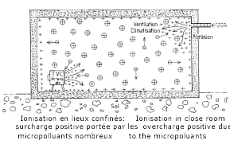
The ground is almost always insulating. Traversed, pressed, rubbed, it fatally will lose electrons, carried and run out by the various drivers present: pipeline water and of electricity, central heating radiators, and you who, in all innocence, will pour them in more accessible places!
In short, very quickly, an overload, which can be significant and of positive sign, will appear and remain stable. Never forget indeed but if the electron can go and come, with an extreme facility, the positive charges, related to the cores of the matter atoms, are literally riveted with this one and can almost never escape some!
Then be not astonished if the clear charge which settles very quickly in a room is positive!
And if, in order to increase your comfort, you have a system of air-conditioning or ventilation, the " turbinate " micropolluants violently will have lost their electrons, trapped by the surrounding conducting structures, and will liberally feed you in positive loads of which they will be the innocent vehicle...
Add to that a fitted carpet thick and soft, a made deep settee of a superb synthetic fabric, light your television set colour and perhaps also a cigarette.....

Good, I stop there, because my electronic probe is likely to explode if, seized of curiosity and perhaps also of a vague fear, you asked me to show some measurements.... oh just!
I should however bring an additional precision here. When I quote the " micropolluants ", I speak of course about the whole of the particles present in an atmosphere; however these particles comprise, in a variable number with the place and the circumstances, of the alive elements, viruses, bacteria, moulds, etc, including one certain number, baptized " aero germ carriers ", are really dangerous, either that they cause serious infections, or which they start of the severe allergies.
However we know that these aero germ carriers charged positively, like any other particle, follows the fate and to become to it those, which constitute besides a support and an ideal vehicle for their dissemination!
It is thus hardly astonishing that an increasing number of social welfare, companies and of course all the mediums of Health are worried more and more problem of which they undergo the impact and the consequences, without laying out for all that solution. It appears to me in fact much more astonishing than it should so much have been awaited so that one evokes finally a situation from which people suffer since too a long time.
 It is observed indeed that the positive densities, recorded in the places thus affected, are always higher than 1 a thousand of positive charge per cm 3 of air, and reach 5 thousands per cm 3 in certain buildings equipped with air-conditioning or ventilation.
Such values are extremely alarming, and emerge besides for the people concerned, on multiple faintnesses or disorders on which it becomes increasingly difficult to maintain silence or the denial.
We will return there. But we must mark this stage in our progression well before, because it reflects at the same time a completely fundamental physical fact for our atmosphere, and an extremely alarming situation for the future of our health. The two proposals which follow then summarize in a brutal but indisputable way the currently known experimental facts, in an unquestionable and systematically checked way.
- a salubrious atmosphere always has weak or very weak micropollution, joined to the only presence of small ions of the two signs, of which a negative charge higher than 1,5 a thousand of negative ions per cm 3 of air, presenting in addition quasi therapeutic properties for densities higher than 5 thousands of negative ions per cm 3
- an atmosphere found unhealthy always presents strong or very strong micropollution, joined to quasi an absence of small - in particular negative - ions, and to a clear positive charge higher than 500 large positive ions per cm 3 of air, generally ranging between 1 and 5 thousands of positive ions per cm 3 .
I would not like to finish this chapter without reconsidering natural phenomena where micropolluants and electric charges, closely dependent, have effects sometimes very significant, often known since strong a long time, on the health of interested populations.
They are in particular the effects observed at the time of the arrival of typical winds of some regions :
the Foehn on all Alps of the South,
the "Autan" wind on the Pyrenees,
the Sharav, come from the desert of the Sinai, in Israel, the Khamsin in Egypt.
It is obviously not only, but in addition to they are familiar for us, they are the causes of physiological phenomena, turbid varied sometimes serious, which to date are indexed perfectly by the medical profession, and objects of studies very followed on behalf of many institutes of research, located around the Mediterranean basin in particular.
The alpine foehn, as its Pyrenean version the Autan wind, occurs in the desert parts of the north of Africa, to the borders of the Sahel. The intense heating of the ground in diurnal period, the very small relative humidity of the air, facilitate immense upward movements of this air, the formation of very strong turbulences and the drive of enormous quantities of micro-dusts up to 10 or 15 km of altitude.
The presence of a significant anticyclone on the Eastern Mediterranean, joined to low pressures on the near Atlantic , involve the increase of powerful masses of African air, overloaded in altitude of the micro-dusts collected on the continent.
Crossing the Mediterranean, they reach the Pyrenees in the west, Swiss and Tyrolean Alps in the east, and give in particular extraordinarily luminous sky . The vision of the snow-covered Swiss or Tyrolean Alps when the foehn occurs is a spectacle of a rare beauty which know and appreciate the mountain dwellers... and those which like a certain light.
This illumination of the sky is due obviously to the intense diffusion of sunlight by the innumerable micro particles present in the upper atmosphere.
And it is without surprise that, from 24 to 48 hours later, one sees occurring the rain, but a quite particular rain, overloaded with these micro particles and leaving, when it evaporates, a fine powdery layer of ochre colour on all things...
It is there the aesthetic aspect, almost poetic of the things! But if it is looked at there more closely, or if there is the responsibility for a centre of cure of pulmonary patients for example, one very quickly knows what the arrival of a " blow of foehn" represents ...
The electrical measurements show indeed that, 24 to 36 hours before the establishment of the foehn, the density of charges of the atmosphere is reversed almost brutally before the arrival of the micro particles; going down again from the stratosphere where it obviously acquired a strong positive charge, the air restores it with the lower atmosphere, destroying at the same time the negative charges usually present.
This situation lasts in general two days, after which the rain occurs which gives all things in order, and makes it possible the lower atmosphere to find its usual negative charge.
The problems arising to the cardiopulmonary patients and to their doctors, on such occasions, are too known so that I insist on them. Let us recall only that many centres of cures in France, in Switzerland, in Austria, in Israel, to quote only those, have collected since several tens of years, the results of regular observations; these results show that a considerable increase in the number of the cardiovascular and pulmonary accidents results quasi systematically from the arrival of the foehn (or of the sharav in Israel).
It is important however to note that these accidents occur primarily before the establishment of the characteristic wind, and before the arrival of the micro-dusts, brought especially by the rain which makes continuation; these facts thus seem to exclude, or at least to reduce very strongly, the clean action of this micro-dusts on the behavior of the patients. It is thus extremely probable that here still, as in good of other circumstances, the role of the positive load on the gaseous exchange of a sick lung must be seriously re-examined for a convenient intervention.

Such examples - joints with much of others - must undoubtedly lengthily be contemplated.....
In particular by all those, many, supposed qualified and often " persons in charge ", who persist in against any obviousness thinking, but especially to claim, that these phenomena are to some extent the folklore of physics.
By those which, resigned and sometimes discouraged by the first, think that we are disarmed in front of a kind of fate. By those finally which, exactly informed of the facts of the case, if not of its possible solutions, neglect or refuse, for " various " reasons, the study and least implemented of such solutions.
But while time is lost, the evil progresses! I will finish this matter by the recall of a short official statement of the French Ministry of Health, diffused on a chain of television in April 1990, which alas did not lose anything of its topicality:
" the services of the Ministry and the medical environments are very worried about the regular growth, very significant during this last winter, however particularly soft, of the rhino pharynges disorders of the young children, disturb often accompanied by pulmonary complications."
This alarming report did not cease any more being confirmed, without for as much are adopted other thing that... projects of resolutions !...

How long still " the blue planet " will it be able to accommodate us?

Chapitre 4

AIR IN DANGER

CHAPTER IV

PROBLEMS AND SOLUTIONS

1 - SOME EDIFYING PARADOXES

It is always instructive to examine closely the arguments known as " of good direction ": they generally lead to comical conclusions... or dangerous, very seldom with advantageous discoveries for those which suffer. Here a first example.
We know all that as we rise in the atmosphere, the pressure of the air decreases, and with it the quantity of oxygen available. Between 1000 and 1200 meters of altitude, this quantity of oxygen available decreased by approximately 18 % compared to the sea level. On the other hand, we recall that the rate of micropollution is generally very weak, the negative ionization rate very high.
Except these three factors, whose only one with " officially " being recognized is obviously the pressure, other factors - hygrometry, temperature, wind, sunning, etc .do not differ hardly on average from those which one meets " in bottom ".
An organization tired, depressed, subjected by the constraints of the urban environment to a permanent under-oxygenation, imperatively needs a periodic return to a normal oxygenation. It could even be necessary to impose an auxiliary oxygen treatment to him, by enriching the ordinary air by a supplement of pure oxygen. No one would not have the absurd idea to then propose a stay in depression chamber, where one would lower the rate of oxygen from 15 to 20 %!... in spite of the moderate cost of such a stay " in altitude ".
Therefore the stay - especially prolonged - of an organization tired on average mountain, at an altitude from 1200 to 1500 m, is absolutely to proscribe !
All things considered, in the name of the " good direction ", consolidated by the data of the physiology of breathing, it seems completely excluded to observe a favorable effect then! However we know all, to have lived it, which extraordinary well-being we test finally in this air however " rarefied ", but so pure, so " light ". Would this be thus a simple illusion, a " psychic " effect? This last aspect is certainly not negligible, but its possible impact remains completely marginal. Whereas does it remain ? Could it be for example that the barometric pressure plays finally only one rather secondary role, the first roles being then held by... ionization and the quasi absence of micropollution, only able to allow an excellent oxygenation under a pressure of air already definitely reduced?
In nap dreadful a good direction should already have warned to us: " Why to have much oxygen good if one can't use it well?" Question how the unhappy inhabitants of these places of altitude, private of air without appearing to suffer from it, could pose to people " of in bottoms " provided so much better!
But which wanted, in the world " of in bottom ", to draw a conclusion from it and from there a rule of life?
And which will be able to deny that it is easy, too easy, to absorb a tablet anti ache, a capsule of tranquillizing: it is enough to read a dosage and to swallow the tablet or the capsule, by hoping that the relief will come and that the " remedy " too often renewed will not involve a worse evil.
This undoubtedly brings me to the second paradox, less obvious, and which always fits in these crazes of physicist of which I do not manage to demolish myself!
The ionization of the atmosphere has been known and studied for soon a century, its effects on the living organisms studied and known for more than seventy years .
Thousands of work and publications clarified this subject, work very often due to men of science of world fame, forts of a solid knowledge and with a wealth of an immense experiment.
Of this innumerable work arises the completely convergent experimental conclusions that the remarks or lived never cancelled
- the negative oxygen ions are always present in an atmosphere healthy, salubrious, with a density all the more high since the atmosphere is purer;
- no experiment never could highlight the least harmful character of negative the oxygen ions, neither on the animals nor on the human ones, even with the most considerable densities and after durations amounting of tens of years
- all the observations, made on exceptionally salubrious recognized sites, places of " cures " of all kinds relating to the pulmonary diseases particularly, showed the double systematic presence of a high negative ionization, associated with a very weak local micropollution of the air;
- the presence of a strong excess of large positive ions and the correlative disappearance of the negative oxygen ions always occur in the places where reign a significant micropollution;
- the subjects placed in an atmosphere with strong positive overcharge (animals or human) quickly express disorders or varied faintnesses, being able to become serious in the event of prolonged exposure. The return to an atmosphere with negative prevalence involves the disappearance of these disorders or faintnesses and the restoration of the health;
- these disorders and faintnesses occur in a number growing at the people of which working conditions and the environment comprise a strong well identified micropollution, and the electric imbalance of the ambient air which in results ;
- these disorders and faintnesses are particularly raised in the closed buildings provided with systems of recycling of the air and where function strong sources of positive ions (video screens in particular).

It thus is currently allowed to affirm, not under a free and contestable assumption, but within sight of facts recorded and checked since soon hundred years, that the electric state of the air in which we live, in close relationship to the nature and the quantity of impurities which it can contain, is one of the fundamental factors of our physiological balance and our maintenance in a satisfying health.

He well, all occurs as if this biological obviousness, and the indisputable physical facts on which it rests, were regarded as plot or daydreams of scientist!
And to fight effects that nobody can obviously deny, one is then constrained to use a chemotherapy of which nobody disputes the utility, but who is impotent in front of problems which it is naturally unable to solve.
Admittedly, no one can deny that in the presence of symptoms unpleasant or painful, it is often urgent and legitimate to fight such symptoms as fast as possible.
But no one will not claim either that, thanks to the immediate relief obtained, one can give to later the care to deal with the causes!
However, by a strange perversion, one asks chemotherapy to fight here only effects, due to causes which are completely foreign for him, and to which it is completely unsuited. The ransom to be paid is known: in addition to a precarious relief, they are all the side effects of the drugs thus consumed without reserve, the immense wasting which they maintain....
It is an attitude, rather an abandonment, which we must and can refuse, because there is not in all that null fate.

We have, I hope for it, well defined and determined the causes of our problems. As it is the rule in this nature, a correctly posed problem comprises the elements of its solution; and it is not only true with problems of mathematics!...
It thus remains us now to take the last step, to undertake the urgent task: to conceive then to carry out the restoration of a mutilated atmospheric environment and to find, simply, which nature never ceased offering to us without counting.
That made, we will be able finally..... to breathe !

2 - MICROPOLLUTION, IONIZATION, HEALTH:
IDEAS AND AN ASSESSMENT

In front of the serious problems that the micro pollution of the air poses - for us, but more and more for the children, particularly vulnerable - I said and I will not cease repeating that there is neither fate of the thing, nor impossibility of treating it.
I thus will endeavour to show you how a " good use " of concepts sometimes rather abstract can lead fortunately to completely concrete solutions and in addition very, very effective...

Thus let us start by returning on what is in sum the cause of all our problems: micro pollutants and their generally positive charge.
We saw that the things are unfortunately not the same ones inside a room, whatever it is. Ground and walls insulators, charged on average positively, prohibit the capture of the big positive ions, situation that all measurements confirm.
Let us look at table N° XVI now: it shows us the fundamental mechanism by which a particle, neutral or charged positively, can be affected by the presence of antagonistic charges, here negative.

Table 16

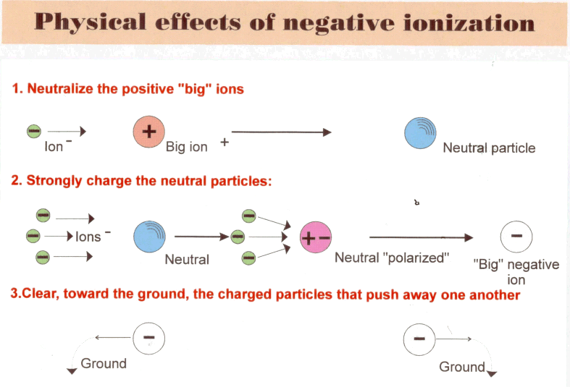

Thus let us inject into the atmosphere of a micro polluted room a small quantity of electrons (they will be of course ions (0 2 - .
Initially, the large positive ions (not very mobile) will attract towards them the very mobile negative ions, and will be thus transformed into neutral particles. It is a first encouraging result, because the harmful effect suitable for the positive charge will be already more or less mitigated.
 It is unfortunately very insufficient for two reasons at least:
- the micropolluants remain in the atmosphere because of the properties recalled to the chapter first,
- these same micropolluants remains able to acquire a new positive charge, created by the ambient sources (remember radon in particular).
If thus the quantity of negative ions injected is weak, we will have obtained only one poor result and in particular, we will have eliminated neither the particles responsible for allergies nor the infectious germs. As much to say that this form " of aéro-ionization " is quasi useless and that it maintains the dangerous illusion of " cleansing ", almost non-existent in fact.
Completely inapt to ensure a real and permanent depollution, it will lead its user to feel justified disappointment and mistrust: a perfectly effective natural process will simply have been betrayed by an incoherent use.
Thus let us return to our micro polluted room. Let us take now a source of electrons (thus of negative ions) enough powerful to ensure the complete sequence of the events appearing in table N° XVI:
- initially, the strong density of negative ions injected into the air will involve their fast capture by the big positive ions present and will neutralize those;
- these neutral particles, subjected to the intense electric forces created by the negative charges, acquire a " polarization " involving the capture of one or more electrons; the big negative ions thus created carry a negative charge then growing like the surrounding negative density, thus being able to reach a high value (such an effect was envisaged theoretically and proven in experiments (cf. Bibliography at the end of the text) by German physicist LADENBURG (published in 1930 in famous Annalen der Physik in BERLIN) and French physicist PAUTHENIER (published in 1932 in the Reports of the Academy of Sciences, Paris...). Moreover, all the particles present , whatever their dimensions or their nature, acquire such a load negative ;
- this significant electric charge then will involve an increasing mutual repulsion of the particles of micropolluants, sufficient so that their diffusion and precipitation towards the ground of the room (charged in general positively, cf. table N° XV) is started and continues regularly.
Besides to this end " kinetic " purely is added a second effect quite as significant on the aero contaminants present, bacteria, virus, etc, effect specific to the only negative ions: it is observed whereas the strong electric charge acquired by these varied germs, very quickly blocks their essential exchanges with the atmosphere, thus resulting in their death (effect checked by Finnish and American works in the Seventies – cf. Bibliography).
One is thus in the presence of a true germ-destroying process. Thus the double operation will then be carried out for which I stated the need :
- to bring back the rate of the residual micropolluants to that of the natural places most salubrious,
- to restore the permanence of a negative overcharge of the air identical to that of these places.
They are there effects being able to be qualified primarily of " physics ", strictly related with those which one meets and observes in external natural environments, far from any intense source of micropollution.
Their existence and the quality of the results observed, as well in test laboratories as in real sites of dwelling, would be enough to justify of it - or rather to recommend some - the generalized use.
But, as I recalled it at the end of the second chapter, the presence of the ionized oxygen in the atmosphere is contemporary appearance of the life; this one had to integrate this fundamental and permanent factor in its daily unfolding and its evolution, in particular on the level of the respiratory and cutaneous exchanges.
One must thus expect that a return in an atmosphere provided well in ions (0₂⁻) allows the attenuation, even supplements it disappearance, of the disorders or faintnesses tested in micro polluted air with positive charge. Here still, the results observed in natural sites, but also the observations made in closed mediums laying out of the necessary negative density , and during a sufficient time, agree perfectly and provide almost identical results.
In the very many publications concerning the physiological effects of the negative oxygenates ions , a certain number of sites of action are about unanimously recognized for essential with the demonstration of these effects; it is among others :
- the complete respiratory tree,
- the immune system via the macrophages (white globules known as lymphocytes " killers"),
- the Neuro vegetative system via serotonin and various neurotransmitters.
Not less significant, but of origin more difficult to determine, are the often spectacular effects on:
- tiredness, its arrival, its recovery,
- general tonicity, vigilance, the aptitude for the effort, the pain (cutaneous burns, ulceration's, but also rebellious cephalgias, migraines).
Lastly, of very many observations (inter alia in the cribs of urban children) confirm, during periods of epidemics in winter, the undeniable protection brought by the installation and the permanent maintenance of a high negative density.
Such a protection is neither surprising nor additional: it results from the two fundamental properties of a sufficient negative ionization of the ambient air: the germ-destroying effect on the aérocontaminants present and their precipitation at the ground, but also the unquestionable action on the organization, in particular on the immune system and natural defences.
The majority if not the totality of the recorded failures, as well as the irregularity of the results, remain closely related on the characteristics of the apparatuses used, the conditions of use, and confirm the peremptory necessity to use perfectly sure sources and sufficiently powerful Such an obligation will be all the more pressing besides since the room to be cleansed will be of greater volume and object of a strong micropollution, while the number, the provision and the characteristics of the apparatuses will be the subject of a preliminary thorough study.
Let us reconsider one moment the biological effects of our negative oxygen : we know that it is narrowly implied in several physiological mechanisms completely essential with our life - if not our survival - which I will very briefly point out.
First of all, of course, breathing or more exactly the mechanism by which, on the level of the " membrane " which papers our air cells, is done the fundamental gaseous exchange. It is there that the oxygen, brought by the air inspired, gains the network of capillary vessels surrounding and is collected by haemoglobin. In the same moment, carbon dioxide leaves this haemoglobin and the blood of the capillaries, crosses the membrane of the cells and is evacuated towards the atmosphere. All this process complexes proceeds in a few seconds, with each inspiration and expiry...
It is here that negatively ionized oxygen seems to play a completely essential role, by ensuring a transit much easier and rapid of the molecules of neutral oxygen, immensely more, and consequently facilitating the opposite transit of carbon dioxide. The respiratory " output " is some increased, in the same way of course as the oxygenation of blood and its " purification ".
If it is obviously necessary to be kept of saying that in the absence of negatively ionized oxygen, we would die asphyxiated, it does not remain about it per less that in this absence the " respiratory output " is clearly decreased, the exchanges reduced , and that the disorders observed systematically in such an atmosphere occur then when the people concerned present a respiratory deficit.
The second field, in which the molecule (0₂⁻) plays a fundamental role, is that of our immunizing defences, in particular in the essential phase of the destruction of a foreign body (bacterium, cell, etc.) by the " white globules " responsible for this task and called " macrophages "..
The third field, in which we have all the evidence of the essential role of negatively ionized oxygen, relates to a completely fundamental chemical substance of our organization, true molecule " conductor" : the serotonin.
At the same time messenger and actor, this molecule is present everywhere and is worth us besides often serious nuisances. You owe him in particular severe and tough migraines, without speaking about the innumerable inflammatory problems from which we suffer always more or less. However such nuisances always result from the presence of a serotonin excess in our blood plasma and translate in fact a true " state of alert " of our organization in relation to an interior or external aggression.
In particular, a positively overcharged and micropolluted atmosphere maintains a systematic excess serotonin in blood and can thus involve the appearance of all the disorders resulting from such an excess; contrary, an atmosphere with sufficient negative charge makes it possible to observe a true regulation of the serotonin rate, that the organization controls again fully.
To finish some with these concrete examples, a case should be quoted where seem to combine itself and to harmonize the properties of this ion (0 2 - : that of the cutaneous wounds by burns or ulcerations subjected to a sufficiently intense flow of negative ions. Here, the observation is easy, the results immediately visible and recordable, in particular by photography .
Whoever saw and intended a very young child to hopelessly seek his breathing during one night whole, cannot remain indifferent to the problem. Here still, the negatively charged air, and of this fact largely removed from the aero-allergens present, brings to the small patient a relief which always leaves at the same time the delighted observer, relieved, but passably doubtful . I add that such a result, observed on multiple occasions and easily verifiable, is obviously not the prerogative of the young children. Simply, it is much more difficult to call upon in their cases a " placebo effect " " of circumstance ", completely impossible since they are perfectly unaware of the means then used, like their possible effects!!
Let us retain however that such results should not absolutely enable us to claim that negative ionization is the panacea, remedy for all the come evils and to come! It is registered more modestly, but with its own indications and its undeniable effectiveness, among the best means than nature places at our disposal to relieve or prevent some of our evils. I think that it is amply enough to justify it!
And I thus will get busy, in what follows, showing how can and especially how must, being implemented such a means to bring to us what we can expect.

3- ACTIVE AERO-IONIZATION : WHICH SOURCES ?

One would of course be tempted to answer: " natural " sources, obviously, if one is likely to live in a permanent way in a place of perfect healthiness: clearing of mountain, foot of a cascade, snow-covered slopes...
Such permanent stays being reserved only for one rather reduced number of our contemporaries, it will be necessary for us well to have recourse to an " ionizer" !
Thus let us return to our problem: to find the best possible source of electrons, therefore of negative oxygenates ions , i.e. a source offering the ideal efficiency with the minimum of harmful effects and ensuring inside a room the concentration of ions (0₂⁻) considered to be necessary, whatever may be "a priori" the volume of the room and the ionic concentration required.
Nature offers to us in practice four possible sources of electrons, more or less directly usable. Thus let us see if such sources have the exigible characters ..
a) Radioactive sources and radiation U.V.
These obviously are - though natural ! - sources " with risk " which, except very particular cases, will never be used for a usual ionization of inhabited buildings.
b) " Thermo ionic " sources
One thus names sources able to emit electrons when they are heated. What we call " heat " is only, indeed, the result of perpetual agitation, around their position of balance, of all the atoms or molecules of all the existing bodies. A piece of burning iron, it is a piece of iron whose atoms are agitated frantically!
A piece of ice, it is water whose molecules ceased their agitation until enabling them to join in a compact solid; in the ice, like besides in iron in a solid state, atoms and molecules are satisfied to oscillate indefinitely around their average position, without destroying the global structure.
Well... And electrons, in all that? A little as beans in a pan which one shakes: as a long time as the jolts are moderated, you will not lose beans! But if you increase agitation (the temperature of the piece of iron), then caution with the bean leakages, and the escape of the electrons, that the increasing agitation of the iron atoms starts to project outside.
And, of course, more you agitate the pan, more you lose beans: the more the temperature of the piece of iron increase, the more it emits electrons! This phenomenon is abundantly made profitable in the multiple electronic devices which surround us, and particularly in all the " tubes " intended to provide us images: data-processing screens, television sets, inter alia....
Then, we have the solution?
Not, unfortunately, and this because of oxygen because a piece of iron, especially heated, places at the disposal of this oxygen a genuine basket of electrons.
Without same waiting until those left their atom, the molecules of oxygen will make a rush on the iron atoms, clinging thanks to the electrons thus lent, and to give us " rusted " iron !
That made, good-bye with the electrons, finished the external emission, finished the ionization of the air! And this is alas true for almost the whole of the metals, made thus unusable in the air by way of " hot sources " of electrons.

c) " Soft " sources :
Two of them constitutes really appreciable sources of electrons, therefore of ions oxygenates negative: green sheets of all the plants lit by sunlight and the cascade or rainwater drops.
The contribution in ions (0₂⁻) of the plants is considerable, not because the power of the emission is very low, but because the quantity of these plants is enormous, and that they are still largely widespread.
The contribution in negative ions due to the rains relates to especially the strong downpours, from the medium to the end of storms, and thus keep a very specific character ("negative rains").
And the contribution due to the cascades, located in theory in mountain, remains obviously narrowly localised with the site concerned. Let us specify immediately that the use of " cascades " or equivalent in apartment brings to the user a completely appreciable environment, but alas very little of negative ions usable!
For essential that are thus the interest and the contribution of these sources in the external medium, their use in the closed buildings is obviously excluded, or at best completely additional. There thus remains a last possible means, that which nature implements at the level of the sheets of conifers and the lightning conductors inter alia: it is " the effect of point " still called " Corona effect ".
d) The effect " of point " or " Corona " (or " crowns")
Table N° XVII summarizes the essence of this phenomena : one will make an effort to accumulate at the end of a very sharp-edged " point " the greatest possible quantity of electrons. The point will be obviously made of a conducting metal particularly not very miserly of its electrons (Nickel, Gold, etc.)
Table 17

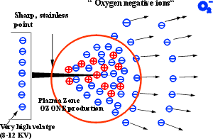
To obtain such a result, it is obviously necessary to provide to the electrons of metal a good reason to flee their asylum. In the truth, simplest will be to have an external source of electrons, in the shape of a generator with very high voltage, able to provide the energy of wrenching to the electrons of the point. Pushed, hustled, piled up towards the point, they will be constrained to jump in the " vacuum "!
 It is exactly what occurs and one observes moreover than one same generator of very high voltage (VHV of table N° XVII) will provide a number of electrons all the more large since the point is more " fine "; we will say more precisely " all the more large since the ray of the end of the point is weaker ". Moreover, for the same point with the same final ray, the number of electrons grows quickly when the tension applied to the point increases.
It would be then trying to say: " to have an intense source, rather than to endeavour to manufacture extremely fine, fragile and delicate points to use, let us use more rustic but robust points, under a higher tension."
It is there a new example of the harmful effects which a ill-considered use of the " good direction involves ": it is indeed easy, therefore trying, to increase the tension applied to the points and almost the totality of the manufacturers does not deprive itself any!
The trouble is that one of the usual means to manufacture ozone - you remember, this variety of oxygen with three atoms - is precisely to carry a driver, in particular a " rustic " point, with a raised tension, higher in fact than 5000 volts. An additional trouble is that the produced quantity of ozone grows very, very quickly when the tension of the points is increased, involving very quickly for the user a serious and obviously unacceptable risk.
And as a trouble never arrives only, another difficulty also will arise: that of the creation of a " plasma " of charges, whose presence strongly reduces the output of emission of the point, but especially is responsible for the creation of undesirable ozone!
What is this thus still that this plasma?
In what concerns us, source of additional troubles , which is easy to understand considering what precedes, but less easy to fight! And here why.
If you return in table N° XVII, you see there that, by its nature, this plasma plays an energetic role of brake with regard to new electrons resulting from the point, and that it thus tends to reduce the emission very appreciably: installed in front of the point, any fan, therefore powerful it is, will never manage to dislodge it... while it will ensure a broad distribution of ozone produced !....
The problem is now clearly posed :
- to have the electrons and the ionised oxygen which we need, one would need a strong tension applied to the points, but the ozone produced in quantity would make the apparatus dangerous and unusable what the experiment proves immediately;
- then, it would be necessary to operate with moderated tension, without production of ozone... but with an output in electrons very decreased and poor or null results in particular concerning depollution and decontamination, which proves pitilessly the experiment.....

For almost the whole (except for an exception) of the currently marketed apparatuses, the adopted solution is a compromise between the two requirements: one operates between 6000 and 12000 volts by producing an ozone rate which claims to respect... " the international standards ", but which quickly becomes intolerable for the users, in particular the all young children and the fragile or sensitive people.
It is however interesting - but worrying - to note that these " standards " vary very largely on both sides from Atlantique : the American standards tolerate 0, 1 " part per Million " (which one writes 0, 1 ppM) or " 100 ppB " (part per Billion) of ozone in the places " intended to accommodate the people "; the Russian standards, more severe, tolerate only 0,05 ppM (50 ppB). As for the O.M.S. (the World Health Organization), seized of increasing pollution due to ozone, it studied the problem for a lowering of the tolerable rate very below the Russian standards.
Let us add that in France, inter alia, there is not imperative standard and that this gap in the law - largely exploited by the manufacturers - does not support protection against ozone....
Let us add finally that the prolonged stay in a place containing more than 0,025 ppM (that is to say 25 ppB) of ozone can involve more or less severe disorders or accidents for the famous individuals " sensitive ".... but also for the others.
still set us recall that the ozone emission is inseparable from the production of oxides of nitrogen, very aggressive substances towards the mucous membranes of the respiratory tree and the cornea, inter alia. It is to say once again that the electric characteristics and the nature of the emissive point will not be enough in no case to qualify an equipment and that it will imperatively be necessary to take into account the globality of the problem. It is there pure and simple problem of physics, and more exactly of this completely abstract and passably unpleasing part that one names " electrostatics ". Courage ! We... almost arrived.
Because from now, if we apply with a perfect rigour the fundamental rules that nature proposes and imposes to us clearly, we will end without surprised to the results until we wait.
Without surprise, but at the price of a long adventure, rich in difficulties and developments !
It is a little this adventure which I now will tell you.
Soon thirty years ago (I write this in 1999) that I tackled the problems of the physics of the atmosphere, and that I learned to which complex phenomena I was going to be confronted. With this very complexity being added their unquestionable impact on the beings living in this atmosphere and thanks to it, even if this impact were not perfect obviousness.
And so that measurement was packed, I was going very quickly to learn that these alive beings could in return modify or disturb the most essential characteristics of the air of which they lived!
Very quickly also I noted the importance of the electric phenomena - the ionization of the air - on the state and the behavior of these same living beings . This led me to take part, in university laboratories, with the direction of several biological research tasks with a new generator of negative ions which I had designed.
Sanctioned by a thesis of doctorate inter alia, this work confirmed what we then knew of the effect of the ions of the two signs on the alive medium.
These various circumstances having led me to ensure a post-doctoral university education, I was going naturally to be led to widen the field of investigation which arised at me, in order to obtain if possible a complete vision of the phenomena. Thus, with the passing of years, from the innumerable articles or documents read and analysed, from the multiplied experiments, from the accumulated results, was going to constitute the solid screen on which the achievements are pressed in question in what follows. But before that, one precisely needs that certain rules are pointed out and specified, precisely those which emerged from this long study, and naturally were essential.
The experiment then proved unceasingly that they must be very strictly respected so that the equipment implemented ensures us without fault the essential effectiveness and harmlessness.
Here thus these rules, which make besides only summarize all that was known as with the length of these lines.
1 - The device will have to act permanently on the whole of the volume of air contained in a given room, in order to act at the same moment on the whole of the micropolluants and charges present.
2 - The device will have to act on the totality of the categories of micropolluants and contaminant present ("granulometric spectrum"), extending in fact from some micrometers (limits of the largest suspended particles) with some thousandth from micrometers (virus, aggregates of " big" molecules, etc.)
3 - The device will be, whatever its power, of a total harmlessness (ozone emission and oxides of nitrogen to most equal to that of the natural places most salubrious), thus authorizing its established post in all closed places and near sensitive or fragile people in particular.
4 - The device will have to restore and maintain the balance electric of the atmosphere of a room in accordance with that of a salubrious natural atmosphere , whatever may be the dimensions, the structure, the contents and the conditions of use of the room.
5 - The device will be easily adaptable to the structure and the conditions of use of a room, whatever are dimensions or destination.
6 - The device will ensure a permanent operation with a low fuel consumption of energy returning its cost of moderate exploitation.
7 - The device will have an enough weak cost of use and of acquisition to allow its installation in all the places where it is necessary or justified.
8 - The device will be of simple and easy current use.
9 - The device will have a long permanent utilisation period (3 to 5 years without intervention), as well as a simple and reduced maintenance.
10 - The device will exclude all accessories (ventilators, turbines, etc.) useless and expensive
11 - The device will be quiet in order to be able to function in all rest or places of work, sensitive person or patient.
12 - The device will be able to function normally in aggressive atmosphere without risk of deterioration or danger to the user.

The first conclusion which emerged from this statement was the quasi obligation to have recourse to electric devices , only able to satisfy completely the rules N° 1, 2 and 4 and to bring the best solution to the nine others. These electric devices would consist then, taking into account all that precedes, of one (or several) source of oxygen negative ions for " point effect".
Remained to specify exactly what would be in practice such a source and the requirements that it should satisfy.
It was going to take twelve years of work to have the answer, in the shape of a new apparatus and of its successively improved versions, answering all the imposed conditions indeed.
Subjected to the long torture of the tests and controls in laboratory, then to the same tests in real sites of all natures and all dimensions, the new apparatus brought finally the proof that the obstinacy of the physicist - some would say his crazes - are and will remain always an essential rule !
It also brought the proof that, contrary to assertions too often heard, there was no contradiction between the stated rules , the essential consequence being the opening of a considerable field of application to a technique remained up to now very confined and very disputed.
From all this, it results that what will follow, which relates to all the practical uses of aero-ionization, of course refers exclusively to the new equipment which I have just evoked.
Its characteristics thus make it possible to envisage and adopt these conditions of use within the strict framework of the " 12 rules ".
Of course, any equipment similar to come, which would answer in a way unquestionable and proven the same criteria, would be usable under these same conditions and should thus lead to same results .

Remember: in nature, the same causes never ceased producing the same effects.
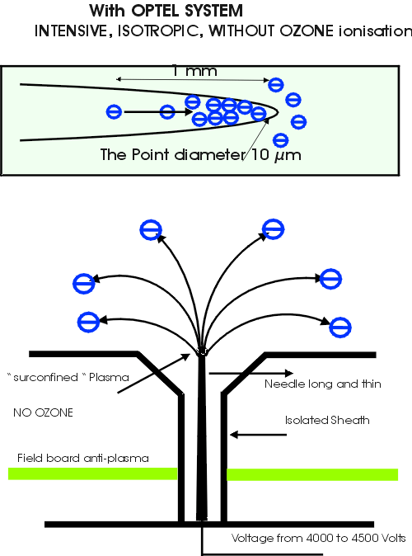

Chapitre5

AIR IN DANGER

CHAPTER V

THE DAILY AERO-IONIZATION

1 - SOME SIGNIFICANT RECALLS

One of the very first things which should well be pointed out unceasingly, as well confusion settled in this connection, and was often maintained with a perfect bad faith, is " aero-ionization is not the panacea with our evils", but how for as much it is not at all a " gadget "!
I hope to have shown you throughout this work how an approach careful, rigorous, resting on known, checked and reproducible facts, allows to understand the nature and the interest of the natural electric phenomena, their impact on our medium, our organization, our behaviour.
Aéro-ionization is not a panacea. But its presence is contemporary of appearance of the life on our Earth, and we saw how the life integrated it into its development and its protection. Any disturbance which will be inflicted to him will inevitably resound on the alive beings which depend on it: can we consume with impunity damaged food or polluted water? However we " consume " daily approximately fifteen kilogram’s of air with all that it contains. And we forget that we " preserve " in our respiratory tracts an average of 20 % of the micropolluants which penetrate there ...
Admittedly our organization is strongly armed to prevent the effects of this permanent invasion: immunizing protections, mucus secreted by the various mucous membranes, cilia of the trachea, contribute to bar the passage to the intruders, to trap or destroy those which continue their advance.
Yes, certainly. But provided that the attackers are too numerous, neither too virulent, nor that the means of defense are submerged...
However the daily experiment proves to us unfortunately that these conditions are too often largely exceeded and that it became urgent to protect us.
Much then believed to find this protection in a " treatment " of the air which would return its healthiness to him and we then saw spreading complex installations, expensive, which in the first time seemed to give satisfaction.
We know now that this satisfaction, the comfort brought to our place of work in particular, has a severe counterpart: the serious, real, checked and endured risk of a broad dissemination of the aero contaminants and all the allergens, with in " premium " an increasing deterioration of the characteristics of the air thus " conditioned ".
In front of these harmful effects, and if we believe someone , would then aero-ionization be only one " gadget ", a little perverse fruit of a fashion which will pass? All, alas, is not false in this reasoning and it is only to observe flowering (generally followed by a disappearance as fast as convenient!) ionizers of all gauges... and all prices to admit that a serious ordering is essential; it is the case in particular of a higher bid disheveled on the level of the announced " performances ", with blow of thousands of billion ions emitted a second, and of " technical " assertions concerning the absolute need for a ventilator, even of a turbine, among others !
And precisely, to begin our course of the " aero-ionized good well ", let us speak about the ventilator!
I mentioned to you above than sole and good way of judging an aero-ionizer, it is to subject it to torture it with physical measurements under real conditions of operation.
Thus it was of the new apparatus, measurements having been made not only by myself, but by people or specialized organizations.
Among these very many tests, one of them transported me pleasure: it is the measurement of the time which it is necessary for this aero-ionizer to create in a given room, whatever it is, maximum permanent density of negative ions (that which will be maintained constant as long as the apparatus will function).
This completely crucial experiment is schematized on table N° XVIII.
Table 18
In the center of a large room of a volume of 150 m3 approximately (8 m length on 6 m of width and 3,20 m height) the source of negative ions is placed, the exits of the ions directed upwards.
The apparatus is shut off : the electronic probe of measurement, placed at 2,50 m of the source, records a low positive density, normal in a place of closed dwelling.
The source is then powering and the stop watch is started; the electronic probe records less than one tenth of a second later the arrival of the negative ions and in 2 seconds approximately the maximum final density is installed in the room and is recorded by the probe.
Of course, this experiment is repeated a sufficient number of times to obtain an average significant value of time . This average always was around 2 seconds, with some tenths of a second near, excellent value, which entirely confirms the total uselessness of the " engine ".
Because the same experiment was obviously made with a ionizer provided with a powerful ventilator intended to increase " very strongly " the output of the apparatus; it was of course the same ionizer with ventilator stopped during the first test.
The result is completely reassuring for the laws of physics: the differences in time of establishment of the maximum density are negligible (about 2 tenths of a second) , i.e. of the order of experimental uncertainties), while the maximum final density proves rigorously equal to that obtained without ventilator or turbine!....
A third series of experiments then enabled me to check how are distributed the ions according to the position of the openings of emissions. Once again, as well with regard to the measured final density as time necessary to its establishment, measurements confirmed as the position of the source was quasi indifferent, and this with or without ventilator
Ultimate measurement, with saying true in the form of challenge: the apparatus being laid out with his exits of ions in the direction opposed to the electronic probe, I could record the instantaneous rise of the negative density, the arrival to the maximum in less than 2,5 seconds on average. This stable maximum differed from less than 1/4 of second from the maximum observed when the exits of the ions were opposite the electronic probe .
To finish of them good once with this problem, then I made the following simple experiment : halfway between the source of ions and the electronic probe and a little behind of the line joining them, I laid out a ventilator intended " to drive out " the ion flow which could not then reach obviously more the probe (the good direction!).
Alas, alas, all that I observed was certainly a fort draught (and an undesirable mixing of dust of the vicinity...), but not the least fall of ionic density measured by the probe.
Here are experimental results impossible to circumvent that a specialized physicist, having necessary equipment, can find and check. They definitively condemn the use of the " engines " on the generators of negative ions, in so far as these generators are in conformity with the rules stated higher and thus able to ensure only the awaited result. I must add that these results relate to obviously the desired small negative ions, quasi molecular, produced by the generator used, small ions with a very great mobility.
The " large ions " that the micropolluants charged constitute, approximately thousand to ten thousand times less mobile, are contrary and obviously sensitive to the movements of the air which contains them. From there come then the majority of the harmful effects of which they are the cause, when they are dealt with by the various systems of " ventilation ", air-conditioning, etc. but we know now that it is an other history .
The conclusion to be drawn from that? It is perfectly clear. We want to ensure the cleansing of a room by charging and precipitating on the ground the micropolluants present in the air. Then let us use for that a source of ions sufficiently powerful, able to ensure this load and what follows, but let us avoid at all costs creating completely undesirable turbulences of air and the handing-over in suspension of micropolluants which we seek to eliminate!
I could add that the noise of the best ventilator is never negligible, that it can because of wear quickly become unbearable, and that its consumption of energy (wasted) reached 20 to 50 times that of the source of ions!
In is necessary it more to give up this superfluous and harmful accessory finally!

3 INTEREST? PERFORMANCES? SAFETY?

A question is often asked to me by those which consider the services of an aero-ionization become almost the ultimate recourse: " should it be used permanently and that is not likely it to present disadvantages?"
Is it still necessary to insist much to convince you of the obvious interest of a permanent aero-ionization of your environment, when this one underwent a deterioration to which you are sensitive?
All things considered, the question could be: " is it healthy and reasonable to breathe only of time to other a salubrious air, when one can breathe it permanently?"
In fact, if I believe of them the many conversations which I had on this subject, they are wholesale three concerns which seem to prevail.
Initially the harmlessness of the implementation. We saw that to date no experimentation, no prolonged use, could not highlight an unspecified harmfulness of the negative ions free from ozone whatever is the concentration or the period of validity.
Only transitory benign effects were observed at certain people: excessive tonicity and maintenance of a waking state prolonged, disorder passing yielding to a good provision of the apparatus (or with the good choice of the allure !) by the user.
The second concern is of order operational : " can aero-ionization bring a real relief to the daily harmful effects? And how long will be necessary it so that I observe a real improvement?"
It is obviously difficult to bring a peremptory answer to these questions! It's however undeniable and is today recognized that aero-ionization acts on two levels, that I briefly recall:
- on a preventive level by restoring the characteristics of a salubrious atmosphere, that it removes from its pollutants, contaminants or allergens,
- to a " curative " level, while intervening as I higher brought back on various fundamental physiological mechanisms , in particular respiratory, hormonal and immunizing.
No one among us not being able to claim itself safe from very reached coming from a degraded environment, it is undoubtedly very desirable to use a simple, effective, without harmful effect process and which, we will see it, must with the surplus be inexpensive. Nothing is opposed then to a permanent and prolonged use, of which the effects observed and felt will appear sometimes at the end of a few hours, sometimes after a few weeks, according to the nature of the disorders and the reactivity of the people concerned but also, it should definitely once again be recalled, primarily according to the qualification of the apparatus used.
As for the third concern most often recorded, it is straightforwardly practical! The price of acquisition put aside, and although it affects the decision, the mentioned problem relate to the cost of permanent implementation of the apparatus.
It is perfectly obvious that this cost of implementation grows very quickly when the generator of ions is seen equipped with additional electric devices; paradoxically, in fact such devices constitute the main part of consumption of energy!
The generator of aero-ions which I described comprise in the " average " version (use in apartment, office, etc.) nine emitting points, maintaining in a volume 50 to 100 m3 a density ranging between 3.000 and 10.000 negative ions per Cm3 (that is to say 3 to 10 million per liter of air), depending on the position occupied in the room. Such a power ensures an energetic depollution (checked by analysis in electronic microscopy) and a complete restoration of qualities of the air, of course any ventilator being excluded!
Measured electric consumption (wattmeter) is about 25 watt-hours per day. With the average tariff (full hours, meter rental and VAT included) of 65 centimes the kilowatt-hour, the daily expenditure is thus about 1,6 centime under permanent operation (tariffs Electricity of France).
This corresponds to a monthly expenditure of approximately 50 centimes and to an annual expenditure of about 6 francs.
Now let us take the case of a generator provided with a ventilator: the working installed capacity varies from 15 to 45 Watts according to the notes of the manufacturers.
Daily consumption, under permanent operation of course, thus varies from 360 watt-hours with 1,1 kilowatt-hour, corresponding at respective cost of 24 centimes and 72 centimes.
The monthly and annual costs will thus be established respectively with 7,5 Francs and 22 Francs/month and 90 Francs and 270 Francs/year, according to the power.

Although not very high, these sums is by no means negligible, especially when they relate to a perfectly useless expenditure, to which join besides the already quoted disadvantages. I add that ventilators or turbines are mechanisms prone to wear, therefore to necessary maintenance, and possible.....and always expensive repairs.
And as only one apparatus of this type is generally insufficient to ensure the due results, the cost of implementation (of course without speaking about acquisition) can quickly become dissuasive...
To finish some with this point, it is necessary to evoke the generators of ions provided with diffusers with flavours, and consequently necessarily equipped with one if not two ventilators !
If I do not have any objection to formulate a priori against the diffusion of flavors in the air of a room, I will point out on the other hand that to want simultaneously to maintain the micro particles or the large molecules, supports of the odor, present in the air, and a flow of negative charges involving the disappearance of these same micro particles, seems a step passably absurd ! The more so as the majority of the notes concerning these apparatuses insist strongly in addition on their deodorant virtues....
Then, a good solution: a diffuser of flavors if it is wished . An aero-ionizer always useful , the thing is certain. But above all, not cohabitation!
Let us come now on another subject, whose importance seems too often neglected, even ignored: the safety of use with respect to the electric sector. A aero-ionizer is a device placed at the center of our framework of life, with permanent range of the hand, in particular of that of the children. It is thus essential that the greatest precautions are taken in order to ensure their total safety. However, as regards electrical current, a fundamental law should never be forgotten: " It is the current provided by an electric source which is cause of the danger incurred by that which is crossed by this current ".
It is thus essential that the accidental contact with an electric element of an apparatus cannot in no case to involve the immediate passage of a dangerous current for the imprudent or inattentive user.
To obtain this result, three fundamental precautions can and must be implemented, necessarily in a simultaneous way.
- a very high insulation of the active part of the generator of ions with respect to the alternative network. This result is easily obtained by using a transformer " of entry " comprising two windings (primary and secondary circuits) separated and strongly insulated . It is there a completely fundamental safety member, unfortunately violated deliberately by the majority of the manufacturers of apparatuses of small prices. Because I have personally undergone the very unpleasant effects of them, and because I have received testimonies of severely concussed people, I insist in a categorical way on this point . I add besides that I am very surprised by the absence of any official control in this field, whereas exist and are applied for less " sensitive " materials severe rules as regards safety of the electrical appliance.
This safety " upstream " being ensured, two means are at our disposal to ensure the safety " in down" : limitation of the current, self-checking of the tension.
- the limitation of the current delivered with the " points " by the source of very high voltage to a maximum of a tenth of mill
- iampere, will ensure the perfect protection of the user, including very young child.
- the self-checking of the source of very high voltage will make it possible to obtain a quasi instantaneous fall of the T.H.T. in the event of " excessive " flow, resulting for example from the contact of the user with one of the " points ". This voltage drop will also involve the quasi instantaneous fall of the current as a long time as the accidental contact or the short-circuit will last.
As soon as the incident ceases, the source of T.H.T. will find its normal operation, without to have suffered the least damage in this circumstance .
The simultaneous use of these three solutions then brings a not easily surpass able safety factor , making it possible of this fact to have " open " ionic sources of great power, therefore of high effectiveness.
The purchaser of a generator of negative ions must require thus all the guarantees that such safety requirements (in conformity with the current standards of the C.E.E.) are undoubtedly respected, and to obtain the written evidence and the insurance from it : one is never too careful with electricity, you can believe me!
A last word on this point, in order to answer the question that you will not fail to pose to you, when having accidentally touched the point of the one of these apparatuses (I do not believe in voluntaries!) you will have tested the small pinching and the feeling, moreover not very pleasant, well-known.
The intensity of the feeling, extremely localized, results not from the value of the current, but owing to the fact that it enters by an extremely weak skin surface, and that it excites the local nervous terminations thus highly, but without being able to cause the least damage.
The nuisance will thus result primarily from surprised and will make the user more attentive!
To be complete in this review of the essential characteristics of a generator of negative ions, one cannot forget one of them which, though fundamental, is almost always the object of an inaccuracy or an extremely suspect blur; it is the real power of the apparatus, i.e. its capacity to maintain the density ionic necessary in a room of given size and destination .
The value of the asserted " power " depending alas on the conditions of his measurement, I thus took many measurements of electronic flow of a point placed in various configurations.
Very quickly a reality without kindness was essential: the measured " density " with 1 or 2 cm of the point does not have any physical meaning, and involves quasi a short-circuit: I specified it well besides to you by evoking the existence of " plasma " located ahead and around this point. The density then measured under the real conditions of use (remotely from 1 to 3 m of the source) falls in a ratio of more than 1000 to 1, transforming the ionizer " of shock " into sad and expensive gadget...!
Here still, the user will have to require during the acquisition of the apparatus not an assertion as free as thundering - in " thousands of billion ions emitted by the points " but, more modestly and more surely, the actual value of the ionic density, measured on the one hand in " Faraday screen room " (real total flow of the points), on the other hand in standard room at increasing distances from the source (up to 2 m).
Then only the apparatus will be credible and its preserved user of cruel disappointments...
Must one recall finally that to be reliable and usable without severe nuisances or disorders by the most sensitive people, an aero-ionizer will have of course to produce neither ozone nor oxides of nitrogen ....
I indeed lengthily maintained you, in a preceding chapter, very big problem of atmospheric ozone. I will thus not return there, if not to again insist on the peremptory necessity to avoid his production at rates higher than those of the most salubrious atmospheres . But we should well be understood !
There are two ways of measuring the ozone rate produced by a aero-ionizer:
- in the " average " atmosphere surrounding the apparatus, therefore to 2 or 3 meters of the emissive points,
- at the " exits " of the negative ions, therefore with a few centimeters of the emissive points, where precisely the ozone and the oxides of nitrogen occur .
It is easy to understand that the real rates of ozone, produced in each case for the same measured rate, will differ from a considerable factor of the only fact of dilution in volume!
Here still, a long experiment, comprising the participation of particularly sensitive people, proved to me that only significant measurement was obviously to be made at the exits of the ions. In this case, the verdict of the analysis of the air completely confirmed that of the observer breathing during several hours this same air ionized with a score of centimeters of the apparatus.
And if you are legitimately curious about the technique of analysis, will know that there is only one of them, bringing all the guarantees of reliability and safety: it is the " chimio-luminescence " which exploits the emission of light characteristic of a special substance in the presence of ozone. It is the most significant method, but of difficult use, reserved for the detection of very weak ozone traces. The limit of sensitivity is about 2 ppB i.e. 0,002 ppM, lower than that which one finds in the air more healthy : it is that which the new ioniseurs mentioned above ensure, checked by an accredited Official test establishment, thus satisfying the most severe requirements for harmlessness under permanent operation.
Here still, the user will have thus never to be satisfied of a vague indication ("international standards "... at 0,05 ppM, limit of the danger ! !), but to require a precise statement of the measurements made at the exits of the ions using an approved equipment whose manufacturer of ioniseurs will have to provide the precise references
In all the cases, these are severe nuisances to come that the user will have thus avoided!

4 - A VERY ORDINARY USE

We finally arrived here at the end of this long course ! All things considered, the last questions which you could ask me would be: " And now, how will be used all that and simply will breathe ?! "
Oh well by observing the few practical rules that here, in answer to your questions.
1 - Which apparatus to choose?
- You were inattentive in the course of reading! Thus take again this work in the first page and, this time, you do not let disturb!
2 - I now have a qualified apparatus: which volume of air will I be able to treat?
- the apparatus referred to above makes it possible to treat a room of a volume ranging between about thirty m³ and a hundred m³, i.e. a room, an office, a show, a part of stay, several contiguous parts whose doors of communication are opened, the apparatus being placed in the most central part, etc.
And if this fork from 30 to 100 m³ worries you, remember the properties of the ions. If the volume is small, the walls are close, the capture is strong and the density reduced; if volume is large, the walls moved away, the capture is weaker and the density increased. It is thus established a true self-regulation of the negative density present which thus allows the use of the same apparatus for a wide range of volumes of buildings.
3 - Volume to be treated clearly exceeds 100 m³. Do I have to use a more powerful apparatus?
- Not ! Indeed, in this case, the density is likely to be very strong in the vicinity of the apparatus, without any utility. It is the same problem as that of lighting by only one source, very powerful but plugging and inevitably leaving corners of shade, or by several sources judiciously distributed.
The same applies in aero-ionization: it is always preferable to have two, even several sources of negative ions, when volumes to be treated are significant. Thus one is ensured to profit in all sites from a sufficient and homogeneous negative density.
4 - And now, in which precise place to install an aero-ionizer There are " defended " places?
- It is always desirable to lay out the apparatus in the vicinity of the center of the room to be treated; thus one will obtain a homogeneous distribution of burdens and the best output, with the minimal " losses ". Moreover, the micro pollutants having to gain the ground as fast as possible, the apparatus will be placed preferably enough close to this one: a low shelf, nonmetal will be an excellent support. And precisely, it will be necessary for possible avoiding the proximity of conducting metal surfaces: never not to pose the ionizer on a central heating radiator for example (without any danger, but awkward!)
However, in quite particular cases, the apparatus could be laid out according to a definite need: in bedside of bed for a " cure of falling asleep " intensive, at the foot of the bed of baby for the most excellent cleansing than one can hope.
In fact, it is generally the layout of the premises which will dictate the choice of the site, under the only reserves which I expressed.
5 - Does the apparatus have to function permanently?
- to refer to question 1 and its answer !
6 - What do it occur at the time of the comings and goings outside and when one opens the windows to air?
- a completely transitory fall of ionic density, immediately compensated, which thus prohibits neither displacements nor ventilation.
7 - Can one leave an apparatus under permanent operation in a bedroom ?
- A priori without any harmful effect, as we know it, quite to the contrary.
Indeed, during the sleep, breathing slowed down in frequency and in-depth involves a fall of the gaseous exchange on the level of the air cells; the presence of ionized oxygen then makes it possible to correct this adverse effect perfectly, and ensure in the majority of the cases an excellent falling asleep and a regular and repairing sleep. It is what the result of very many experiments proves henceforth.
With this close however that certain " hyper tonic " people do not accept a strong negative density after the period of falling asleep . The apparatus could then be laid out with profit and without disadvantage in a corridor serving the room or a contiguous part whose door remains open... or regulated on " the good " pace with the provided order !
And for the unconditional ones of technology, there are programmers making it possible to energize the apparatus with selected intervals of their choice. It will be thus possible to ensure in night periods a judicious distribution of negative ions in the form of successive " puffs " not involving a premature waking !
Here still, and provided that the fundamental rules of use are complied with, it is the user who will discover the methods of application quickly producing the best results to him.
8 - Which are the conditions of maintenance of the apparatus? Can I ensure it?
- the absence of ventilator will make it possible to avoid the major part of the clogging of the apparatus. You will observe, with the passing months, the appearance of traces of stains on the external case; a no fluffy dry rag will make it possible to clean dirtied surfaces. On the other hand, one will not have in no case to use aggressive organic solvents (trichlorethylene, acetone, gasoline, etc).
The cleaning of the exits of ions of the apparatus will be done using a vacuum cleaner provided with a soft brush.
9 - Is it necessary to carry out periodically the replacement of " worn " emissive points ?
- Not, these points are in fact genuine needles in conformity with the requirements of a maximum electron emission. Make of a stainless alloy, they thus have a long " lifespan " (several years of continuous operation). Only an aggressive atmosphere will be able to involve the need for exchange of the points, but to intervals of about a year at least.
It is only recommended to withdraw the fine dust which settles on their end, at the end of a few months, using a cotton on a stem, delicately wiped on the needle in an alternate rotational movement.
10 - What does it happen in the event of accidental fall of liquid on the apparatus?
- Nothing good engraves in the worst case! The significant electric parts of the apparatus are protected by the case and a quasi inalterable insulating varnish. The entry of a small quantity of water will thus not have a consequence if so is operated: to disconnect the apparatus, to turn over it downwards resulting and to balance it to drive out water. To wait until it is quite dry. To give under tension. In more " the bad case", the gauged fuse of protection whose apparatus is provided will ensure the immediate cut of the current. This fuse, inaccessible to the user for imperative reasons of safety, will be checked complete and exchange in factory after return of the apparatus.
11 - Is the presence of a aero-ionizer compatible with that of house plants?
- Question which is often asked to me... by the housewives, anxious of the fate reserved for their dear plantations! Oh well, Ladies, be fully reassured. Not only there is not any incompatibility (think of nature which surrounds you!), but a very long experiment, made by myself and much of other amateurs of " winter gardens ", proves with the obviousness that the negative ionization of the ambient air confers on the plants present and their flowers a strength, a glare and a duration properly surprising. Only one exception to this rule: certain " desert " fatty plants obviously seem to prefer an environment neutral or positive, undoubtedly conforms to that of their natural habitat. It will be easy for you to give them satisfaction!
12 - Is the presence of a aero-ionizer compatible with that of the familiar electronic materials, such as hi-fi system, television set, microcomputer, etc?
- Not only it is compatible, but by the restoration of the usual properties of the air which it brings, negative aero-ionization cancels the effects often very harmful of positive electrostatic charge acquired or emitted by the many plastic components of these materials. In the particular case of the screens of the television sets or video-data processing, we know that the injection of positive ions in the air surrounding these devices is fought perfectly and its effects cancelled by a sufficient injection of negative ions. It is to say that the presence of a aero-ionizer is particularly recommended in this circumstance.
13 - A aero-ionizer can it fight the presence of fume (tobacco, etc.) or of unpleasant odors?
- I failed to return you to the question N° 1! How it is far now, I answer you!
Of course, since in both cases, they are micro particles suspended in the air and which tend to remain there. Particles of tar (somewhat carcinogenic....) and of residues of combustion for the tobacco smoke, micro particle of aerosols or aggregate of large " odorous " molecules in the case of the " odors ", these various undesirable elements will acquire a negative charge ensuring their repulsion, then their precipitation on the ground. In this precise case, it could be necessary to have a power of significant emission, involving the implementation of a type of equipment especially adapted and of course available.
It should henceforth be remembered that any particle liquid or solid in suspension in the atmosphere, that it is mineral, chemical, bacterial, viral, fungic, etc. is constantly likely to acquire an electric charge of our choice and, from there, to see itself imposing a behavior which does not depend any more only on this charge and the local electric conditions . These various effects were checked on several occasions in laboratories of physics, and recently by an expert organization, specialized in measurements of atmospheric micropollution, with which it equipment describes here had been entrusted for the analysis of its action. The results obtained completely confirm all until we could wait.
14 - Last question: is negative aero-ionization compatible with the continuation of a medical treatment, or are there counter-indications?
- With more than sixty years of retreat, one to date knows no counter-indication proven with the simultaneous use of a generally chemotherapy medication and negative aero-ionization. Conversely, the use of the negative ions can bring a substantial if not decisive help to medications in progress. It can be by adding their own effects, already exposed, which make it possible to reduce the amounts and to shorten the setting time, except of course the case of drugs whose amount necessary is imperatively fixed: it is the particular case of antibiotics, for example.
It can be also while acting on the side effects, sometimes almost as awkward as the affection as it is necessary to treat, a typical example is that of psychotropic (tranquillizers, etc.) certain side effects are indeed awkward even dangerous in certain circumstances (the loss of vigilance or a certain confusion, among others).
Lastly, in extreme cases, one will observe effects specific to the negative ions which are equivalent strictly to those of molecules of drugs: it is for example an action anti-inflammatory drug via the cerebral serotonin rate and the effect on the obstinate migraines ; it is also the action on the bronchial mucous membrane in infantile cases of obstinate asthma , that the usual vasodilators do not manage any more to contain. It is in fact a quite long list of evils or affections that negative aero-ionization makes it possible to relieve, almost always on the whole, sometimes completely. But I repeat, once again, that we have by no means here a panacea, a kind of miracle cure for all our evils, and that wisdom and measurement are essential, so that imposes also a technique rich with possibilities.

5 - THE ULTIMATE DEBATE...

Always present if not current, this debate results from a fact of experiment as old as the atmosphere: the extreme smallness of the ionic concentration of this one.
Remember: one liter of air contains approximately 2,5.10 22 molecules of oxygen and nitrogen, i.e. the number 25.000.000.000.000.000.000.000 molecules, i.e. 25 thousand billion of billion!
Do you want an idea of this number? If you want to count the molecules contained in a small cubic centimeter of air (i.e. thousandths of liter), at a rate of 5 a second, which supposes a pretty dexterity, you would be with work during approximately 170.000 billion years! The universe having incipient here approximately 15 billion years, if you had begun the calculation with its birth, you would really not be at the end of your sorrows. Useless to add that to measure this number, the physicists did not use this method, sure but a little slow!
Let us return to our liter of air. We saw that it contains on average between one and two million molecules ionized for 2.10 22 molecules, either approximately a molecule ionized for 10 16 neutral molecules (or 10 Million Billion). It is undoubtedly very little, as you will see it, but however by no means negligible....
Take cubic bricks (odd, but convenient for our experiment!) from 1 dm of edge (that is to say 0, 10 m), therefore of a volume of 1 dm³ or 1 liter. And now... courage! You will constitute of it a gigantic cube whose square base will have approximately 25 km on side and of course 25 km height ("the large " pyramid of Khéops is a molehill !!). When you finish the cube, you will have piled up there with few things close 2.10 16 , i.e. 20 million billion cubic bricks. Oh well, the ionized " brick ", finally the ionized molecule of our liter of air, will be represented by only one brick for example of color different, will be placed some share inside the cube and walking there freely. As much to say that if you want to find it, bricks will probably have " to be stirred up "! Indeed....
It is that, the real scale of the ionization of the air. Oh certainly, in certain cases, the density will be up to 100 or 1000 times higher, which will enable us to disperse a few hundreds of bricks " ionized " in our large cube, without this one appearing disturbed about it.
Seemingly only . Because I believe well to have drawn your attention to the hugeness of the electric forces and their aptitude to be appeared even at long distances Placed in its " neutral cube " whose bricks are to some extent " obscure " from the electric point of view, our " ionized " brick will be the equivalent of a source of intense " light "... and for a physicist this comparison is extremely realistic and exciting!
And that changes everything ! Finished the anonymity of our " brick-light " lost among her obscure sisters: it will be locatable, identifiable, acting, even and especially in the middle of an inert and black ocean .
Undoubtedly start you to have a presentiment of what, in nature, can mean " little ", " much ", " near ", " far ", and the extraordinarily relative character of these words, too hung on our human scale.
Now, I will illustrate this example of the brick cube by a well-known fact of the biologists: it is the search of the female of the butterfly of the silkworm by the male, when comes the period from coupling.
At this time, certain specialized cells of the abdomen of the female secrete a chemical substance a little similar to a hormone, which is volatile and will be diluted in the surrounding atmosphere. Secretion relates to thousandth milligram dispersed in tens or hundreds of thousands of m 3 of ambient air . Final concentration of the hormone (which one names " attractant") will be on average lower than that of ionization reaching a molecule for 10 17 molecules of air!
That then gives us a cubic-molecule of attractant in a " large cube " of 40 km side approximately.
Well ! that does not prevent male Bombyx Mori (thus names the butterfly of the silkworm) from recognizing the single molecule present then her sisters and " to go up " to the female for the bridal parade!
Do you want another example? It is that of the retina of our eyes. Its sensitivity is extraordinary, like the facts which follow will show it to you.
By one night perfectly obscure, you let your retina rest lengthily (between 30 and 60 minutes of complete darkness) so that it acquires its maximum sensitivity.
If the night is clear and the air not polluted, you will be able to perfectly distinguish the light of a candle lit at a distance of 20 km . The light thus received is approximately 40.000 billion times weaker than that received by an identical element of your retina, by one afternoon shone upon on the beach .
It corresponds physically on arrival from 1 to 2 " photons " a second, these tiny " grains of light " imagined by Einstein, that our retina transforms, after an enormous amplification, in an electric signal conveyed by the optic nerve to the brain. It is him which finally will interpret this signal like the arrival of an extraordinarily weak spark, but perceptible.
Why these two examples, relating to very different fields? Because they see implementing quantities of energy and forces considerably smaller than those which aero-ionization brings into play . In spite of that and in spite of all the objections of principle, the facts are, irrecusably there: the butterfly " feels " the molecule of attractant, the eye " sees " the light of the candle.
On the other hand, our organization does not comprise sensory sensors (like the sight, touch) enabling us to identify an ion present in the atmosphere, although energies and the electric forces brought into play at the time of the interactions with this organization are enormous and can most probably involve considerable effects... or may be because of that !
But it was not expected that we can " see " the ions! Moreover, with the fact, do we see x-rays or the waves of the radio? They exist however undoubtedly, with their own effects, which we moreover discovered only little by little by the means of the physics, and which we are still far from knowing completely.
All that I could add, inter alia, the example of the hormones, these complex molecules charged to convey information and orders with the various bodies concerned. They are neutral electrically, their properties depend on certain sometimes negligible details of their architecture, without we still knowing why it is thus. It is certain however that these molecules act with concentrations close to those which we have just seen, and which no one cannot dispute any more this fact .
The atmospheric ions are charge carrier free, and this makes them capable of actions immensely higher than those of the neutral molecules. These effects will depend obligatorily on the sign of this charge; they could not never be identical , even if they are not necessarily opposed . And these effects will be particularly intense on the spot where exist normally significant charge distributions : the surface of the membranes of all our cells, in particular those which ensure our relationships to the atmosphere.
It is precisely the case of our cutaneous surface and the mucous membranes papering the whole of the respiratory tree, which are thus the privileged site of exchanges where the charge of the ions is present and inevitably exploits the role reserved for any electric charge on its environment.

All things considered, and to finish some, one could once again state this strange paradox: acting with close concentrations
- the hormones, electrically neutral, exert an action fundamental and recognized, by means that we are unaware of still almost completely;
- the ions of the atmosphere, carrying a considerable net electric charge , capable of intense effects for short distances, purposes which we know, and know to envisage, would be present only " by chance " and would not play of this fact only little or not role.
This last proposal, perfectly contrary with all that the physicists know, observe, measure, shows simply how much the life sciences must henceforth integrate the observational sciences, physics in particular, to open with a real comprehension of the alive world, and to leave thus the era of empiricism and prejudice.
It is a long-term company, roughcast difficulties, obstacles, often of disappointments and false hopes.

But, like the life, it is wonderful !

Epilogue

AIR IN DANGER

EPILOGUE

And not " conclusion ", since now, all can be done and that can open a new chapter of our relationships to the atmosphere!
Relations become difficult, ambiguous, sometimes tragic when our improvidence and our inconsistencies make fatal brutally of technologies which we let us dream to have finally controlled...
But as brutal as is the alarm clock, it should not make us lose our coolness and our confidence.
Because in front of the improvidence and with inconsistencies of much, remain knowledge, prudence and the determination of some, their will stubborn person to make known and to prevail the truth, was it relative, fragile, partial, and often especially disturbing!
Never without any doubt, science did not place at our advanced disposal all at the same time an extraordinary knowledge of the universe, the first true approach of its comprehension and the control of its forces.
But never undoubtedly a crawling obscurantism and stubborn person did not lay out of so effective means, and of such an attentive and benevolent audience, joined to the active complicity of those with which benefits the maintenance from the " statu quo "....

Then let us remember, under a realism which excludes the idealism by no means, but allows him if necessary to continue to express itself, that we do not have finally anything more nor of less to save that ourselves!
Such a mission seems to me completely estimable, and it is with this mission that I ask you to take part, by receiving this long, very long message, but also, and it will be the most invaluable reward for all, while making an effort that it is transmitted and understood by all those which wait and hope...

Pessac, September 2001

Bibliographie

AIR IN DANGER

BIBLIOGRAPHY

For those among you who would wish to have additional data or information, here a short bibliography of most recent work or publications concerning the fields approached in this work (alphabetically), comprising a short summary of work. These documents of course comprise a complete bibliography of work relating to aero-ionization, thus allowing the deepening of the knowledge of the subject.
We in addition propose the texts " in extenso " of the most fundamental publications on the subject, appeared in the greatest international scientific reviews, of which the concerned reader of indisputable data will be able to thus take note. Here still, the abundance and the quality of the bibliographical references will guarantee the quality of reported work, and the base of the document proposed.

"Air Ions : Physical and Biological Aspects", CRC Press 1987. 2000 Corporate Boulevard N.W. Boca Raton - Florida, 3343 1. International Standard Book Number: 0.8493-6535 X - 720 références - Index. Présentation de l'ensemble des travaux concernant l'ionisation de l'air et ses applications éventuelles. Discussion des résulats .

ALLEN - "FREE-RADICAL PRODUCTION BY RETICULOENDOTHELIAL CELLS" - in "THE RETICULOENDOTHELIAL SYSTEM" - Plenum Publishing Corp.1980 . Rappel des propriétés des systèmes cellulaires utilisant les réactions oxydatives .
Apports de la mécanique quantique à la compréhension des mécanismes mis en jeu . Genèse et rôle des radicaux libres, de l'ion oxygène négatif et de l'oxygène singulet

Breton Jacques,"Facteurs physiques atmosphériques et Ecologie",
Cours au Certificat International d'Ecologie Humaine, Universités de Bordeaux I, Aix-Marseille III, Bruxelles (U.L.B., V.U.B.), Evora (Portugal), Genève, Padoue, Paris V, Toulouse III, Organisation Mondiale de la Santé - Les phénomènes électriques fondamentaux : ionisation, champ électrique, conductivité, orages - étude approfondie de l'ionisation naturelle, phénomènes quantiques, l'oxygène ionisé négativement, interactions avec la micropollution, effets biologiques, perspectives - champ électromagnétique et milieu vivant, biophysique cellulaire, électrocinétique membranaire : interactions entre champs locaux et structure, conséquences biologiques et/ou pathologiques, perspectives .

BRETON Jacques . "Mémorandum d'information au Ministère de la Santé, Direction générale de la Santé, sous-direction de la Pharmacie" . Dossier scientifique complet traitant des fondements physiques de l'ionisation négative, de ses caractères et applications, et des résultats obtenus à l'occasion de sa mise en œuvre dans les divers domaines intéressés . Bibliographie jointe . Juin 1993 .

Breton Jacques et Breton Micheline . “Phénomènes ioniques atmosphériques, micropollution et climats : des lois physiques à leur application” . Climat et Santé, G.D.R.102, CNRS , 1994, 11, pp 55-74 . Rappel des faits physiques fondamentaux et de leur impact sur l'environnement et le milieu vivant .

Breton Jacques et Paccalin Jean . Bulletin de la Société Française d’Hydrologie et Climatologie Médicales , Paris . “L’ionisation atmosphérique : un paramètre fondamental et méconnu en Climatologie” . Presse thermale et climatique, 1996,133, N°4, p 287-294 . Rappel des grands mécanismes électriques atmosphériques, de leur interaction avec les paramètres climatiques, et de l'impact global sur le milieu vivant .

BRETON Jean-Marc . "L'aéro-ionisation au cabinet dentaire" . Thèse pour le Diplôme d'Etat de Docteur en Chirurgie dentaire . Université Médicale de Bordeaux II, 1991, N° 9 . Présentation et synthèse très complète des travaux fondamentaux sur l'ionisation négative, ses applications et ses résultats .

Colloque INSERM 1986, "Maladies des climatiseurs et des humidificateurs", INSERM - Molina Editeurs, 101 rue de Tolbiac, 75654 Paris Cedex 13 - 361 références Index.
Rapports des observations faites en milieu hospitalier sur l'effet des dispositifs de "climatisation" et autres; conséquences sur le développement et la propagation des pathologies nosocomiales . Gravité de la situation face à une aggravation systématique de ces pathologies .

Commissariat à l'Energie Atomique (C.E.A.), France, "Le radon et ses risques dans les habitations", A. Rannou, R.G.N., mai-juin 1988, n'3. Analyse des propriétés des roches contenant des radionuclides, tant dans le sol des régions habitées qu'en construction d'habitations . Propriétés des descendants radioactifs du radon émis par ces roches face à leur ingestion inévitable . Moyens éventuels de protection ou de décontamination .

Duboy J.P., "L'aéro-ionisation - Intérêt biométéorologique et thérapeutique"- Thèse de doctorat en Pharmacie, mars 1982, Université Médicale de Bordeaux II - 118 références. Etude de l'action des ions oxygène négatifs sur les paramètres plasmatiques d'une population de rats . Effets observés . Conséquences .

ESTOL, MAKELA and HOVI - "THE EFFECT OF AIR IONIZATION ON THE AIR-BORNE TRANSMISSION OF EXPERIMENTAL NEWCASTLE DISEASE VIRUS INFECTIONS IN CHICKENS" - State Veterinary Med. Instit. Helsinki Univers. Centr. Hospit. , Depart. of Virology, Univ. of Helsinki, FINLAND - In J. Hyg. Camb. 1979,83,59 , and Proceed. 4th Internat. Symposium on Contamination Control, Washington, DC USA, 1978 . Important travail démontrant l'effet germicide des ions oxygène négatifs et la protection qu'ils permettent d'assurer vis-à-vis d'une aérocontamination de l'environnement par un germe particulièrement virulent .

GIRE-SILORET-"RECHERCHE D'UNE ACTION DE L'IONISATION NEGATIVE SUR LE CYCLE OESTRAL, LA NUMERATION GLOBULAIRE ET LA FORMULE SANGUINE DE LA RATE ALBINOS" - - D.E.R.B.H.- PHYSIOLOGIE . UNIVERSITE MEDICALE DE BORDEAUX II ,1982 . Démontre l'action immédiate de l'ionisation négative sur certains paramètres plasmatiques essentiels .

GOURMEL, SCHREIBER et CANELLAS -"CONTRIBUTION A L'ETUDE DE LA CHARGE SPATIALE ET DE SES INCIDENCES BIOLOGIQUES" - - In "Bull. Soc. Pharm. Bordeaux", 1964,103,49 . Démontre l'action immédiate de l'ionisation négative sur des paramètres plasmatiques essentiels .
Ces deux publications, totalement indépendantes, confirment sans discussion le rôle certain de l'ion négatif oxygène sur la physiologie du vivant .

Institut Supérieur du Travail, France, "Première Journée d’Information en France : la qualité de l'air sur le lieu de travail". Supplément au N° 51 "Etudes sociales et syndicales", mars 1989 IST, 15 avenue R. Poincaré, 75116 Paris. Revue des nuisances relevées sur la plupart des lieux de travail - y compris ceux réputés "sains" ou "réglementaires" -

LADENBURG - Annalen Der Physik . Berlin - 1930, 4, p 863--- .
La première grande publication scientifique de ce siècle, à la fois théorique et expérimentale, concernant une étude complète des interactions entre les charges électriques et les particules neutres contenues dans un milieu gazeux (approche mathématique difficile) . Prévoit tous les mécanismes exposés dans notre document principal .

Laurent Dominique - "Comportement des paramètres physiques de l'atmosphère lors des phénomènes de retombées de polluants sur le site de Lacq, France"- Thèse de doctorat, Université de Pau, Janvier 1978 - 42 références. Etude très complète des mécanismes de retombées des polluants issus des torchères de Lacq, en relation avec les paramètres électriques de l'atmosphère du site .

LEHTIMAKI and GRAEFFE - "THE EFFECT OF THE AEROIONISATION OF AIR ON AEROSOLS IN CLOSED SPACES" - - Tempere University of Technology, FINLAND - In "3rd International Symposium on Contamination Control", COPENHAGEN, DENMARK, 1976 . Etude des effets de l'ionisation de l'air d'un local sur la précipitation des aérosols présents . Confirme entièrement les résultats de publications antérieures .

Liu, Whitby and Yu - "On the Theory of Charging of Aerosols by Unipolar Ions in the Absence of an Applied Electric Field" - - Particle Technol. Labor. , Depart. Mechan. Engin. , Univers. Minnesota/Minneapolis . In "Journ.of Coll. and Interf. Science", 1967,23,367 . Etude théorique et vérifications expérimentales du mécanisme de charge - et de précipitation - d'un aérosol en présence de charges électriques libres (ions négatifs ou positifs) . L'interaction aérosol-ions obéit à la théorie cinétique des gaz et non à la diffusion macroscopique, comme le prouvent les résultats des mesures expérimentales . Conséquences pour la dépollution d'un site contenant des aérosols submicroniques .

MAKELA, OJAJARVI, GRAEFFE and LEHTIMAKI - "STUDIES ON THE EFFECTS OF IONIZATION ON BACTERIAL AEROSOLS IN A BURNS AND SURGERY UNIT" -Helsinki University Central Hospital, Depart. of Publ. Health Science, Univers. of Helsinki, Depart. of Physics, Tempere University . In "J. Hyg. Camb." 1979,83,199 and Proceed. 4th Internat. Symposium on Contamination Control, Washington, DC . USA. 1978 . Rapport d'une expérimentation de l'ionisation négative en milieu hospitalier aéro-contaminé . Résultats très positifs obtenus et applications souhaitables .

Olivereau J.-M., "Incidences psychophysiologiques de l'ionisation atmosphérique", Thèse de Doctorat, Université de Paris VI, Juin 1971 - 428 références.
Publication de référence pour les résultats de l'application de l'ionisation au milieu vivant .

PEYROUS and LACAZE-"TECHNOLOGICAL PARAMETERS THAT INFLUENCE THE PRODUCTION OF OZONE IN A D.C. CORONA DISCHARGE" . In "OZONE SCIENCE & ENGINEERING " - - Faculté des Sciences de PAU , 1985,8,107 .
Etudes des paramètres responsables de l'émission d'ozone par des "pointes" de différentes natures ou dimensions . Conséquences pratiques .

PEYROUS and LAPEYRE - "GASEOUS PRODUCTS CREATED BY ELECTRICAL DISCHARGES IN THE ATMOSPHERE AND CONDENSATION NUCLEI RESULTING FROM GASEOUS PHASE REACTIONS" . In "ATMOSPHERIC ENVIRONMENT". Labor. Elec. Faculté des Sciences de PAU , 1982,16-5,959 .
Etude des produits issus de décharges électriques en milieux gazeux et conséquences sur les interactions avec les aérosols présents .

PHILLIPS, HARRIS and JONES - "EFFECTS OF AIR IONS ON BACTERIAL AEROSOLS" - U.S Army Biological Laboratories . In "Internattion. Journ. of Biometeorology"- 1964 ,8-1,27 . Publication fondamentale : étude théorique et vérifications expérimentales de la loi de décroissance d'une population de germes (Serratia Marcescens) en présence d'une densité ionique négative ou positive . Conséquences et applications aux milieux aéro-contaminés .

PAUTHENIER M. et MOREAU-HANOT M. (Mme) - "La charge des particules sphériques dans un champ ionisé" . C.R. de l'Académie de Sciences Paris -1932, 12, p 590-613 . Ce travail établit de façon définitive les bases théoriques et expérimentales précises des conditions d'acquisition et d'existence d'une charge limite pour des particules "sphériques" placées dans un milieu ionisé, ainsi que la valeur de cette charge .
Confirme entièrement les travaux de LADENBURG et prédit exactement les résultats obtenus avec les nouveaux appareils décrits dans notre document .

Quantum Physics / Physique Quantique - Berkeley Physics Course, Vol. 4, 1971 - Librairie A. Colin Editeurs - 103 boulevard Saint-Michel, 75000 Paris.
Cours de mécanique quantique permettant d'aborder un certain nombre des publications citées dans cette bibliographie .

Recherche (La) - France - "La Foudre" - C. Gary, N°211, juin 1989,
p. 722 - 23 références. Pour le lecteur intéressé au mécanisme des orages et à leur effets ou conséquences .

SAWYER and VALENTINE -"HOW SUPER IS SUPEROXYDE ? "- In "ACC. CHEM. RES." /AMERICAN CHEMICAL SOCIETY - -Labor. of Chem. University of California ,1981,14,393 . Etude approfondie des caractéristiques quantiques de l'ion oxygène négatif en rapport avec ses propriétés physico-chimiques . Conséquences pour les applications de l'ion oxygène négatif au milieu vivant ("aéro-ionisation") .

Whitby, Liu & Peterson - "Charging and decay of monodispersed aerosols in the presence of unipolar ion sources" -, Mechan. Eng. Dep. , University Minnesota/Minneapolis - In "Journal of Colloïd Science", 1965,20,585 . Etude théorique et vérifications expérimentales des lois d'interaction entre charges électriques libres (ions) et particules d'aérosols de toutes natures (Cf. PAUTHENIER, LADENBURG, etc) . Accord complet entre prévisions théoriques et résultats expérimentaux : capture et précipitation des aérosols . Applications à envisager .

___________________
______

AboutTheAuthor

AIR IN DANGER

ABOUT THE AUTHOR

BRETON Jacques - born 17/03/23 in Angers (France). Doctor of Physical Sciences, rank of State,
Officer of the Academic Palms,
Knight of the National order of merit,
president Scientific Director of the Center of Studies and Bioclimatic Research of Aquitaine,
Vice-president of the University of BORDEAUX I-SCIENCES (1970-1977),
Professor of Physics to the Faculty of Science, University Bordeaux-Sciences (....1990)
Responsible for Teaching to the International Certificate of Human Ecology.

Disciplines taught during the university activity :
- fundamental Physics in second year of University: crystalline physics, harmonic oscillator, refractivity; elements of quantum Physics, application to the photoelectric effect, the black Body, etc; atom of Bohr-Sommerfeld, spectroscopy, magnetized mediums, Para magnetism, ferromagnetism . Elasticity of the solids, tensor of the constraints, propagation of a shock; study of the deformable mediums, viscous flow, Reynolds number . the theory of Restricted Relativity (second year of University) - Complements of Mathematics intended for the future Geophysicists (preparation with the Doctorate): operators, calculation symbolic system, algebra of Fourier .

Physics of atmosphere (to the International Certificate of Human Ecology, Universities of Bordeaux I, Paris V, Toulouse III, Aix-Marseille Ill, Brussels / U.L.B., V.U.B., Evora/Portugal, Padoue/Italie, Geneva, the World Health Organization) . Fundamental electric phenomenon's : ionization, electric field, conductivity, storms
- thorough study of natural ionization, quantum phenomena, negatively ionized oxygen, interactions with the micropollution, biological , prospects - electromagnetic field and alive medium, cellular biophysics, interactions between local fields and structure,
biological and/or pathological consequences, perspective.

Personal works

Fundamental works : Study and realization of new electronic circuits (generating of controlled tensions); applications in electronic Resonance of spin (direction of Thesis of doctorate) and in cellular biophysics (degenerative mechanisms).
- electronic " light " Methods of investigation in Geophysics:
impulse electronics, signal processing, interpretation (direction of Theses of doctorate),
- Ionization of gases by " crown effect ": theoretical and experimental studies; realization of the first generator of ions (of the two signs) with " super-confinement of plasma ", great power without ozone emission (deposit and attribution of international Patents)

Research and studies:

- atmospheric ionic Phenomena: action on the alive medium (direction of Theses), studies on cellular medium (Faculty of Medicine, Bordeaux II), study of the relations between ionization and micropollution (with the Electronic center of Microscopy of the Faculty of Science), clinical studies of the effects of the ionization of the air.

- Biophysics of the cellular membrane (" non stimulant " interactions between " controlled " electric fields and membrane, applications to he " degenerative " diseases).

- Scientific department of the Center of Studies and Bioclimatic Research of Aquitaine: installation of an infrastructure of telemetries of the local atmospheric electric parameters, collection of the results, data processing and correlations with certain
pathologies. Publication of original works to "Journal of Geophysical Research" .. Coordination of work and activities with the other European Centers (Freiburg I B, Munich, Garmisch-Part./RFA, Saint-Moritz/H, etc.). Organization and participation in the meetings, Conferences (participation of the C.N.R.S.) etc.

______________________

